**DNS (Domain Name Service)**

Human understandable name to system understandable IP address and viceversa..

Route: In **Networking** Data is sent from source to **DIFFERENT** dest. inform of packets is called routing. Device used is called as router.

DNS port number: 53. So they used name Route53.

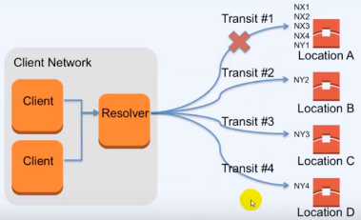

**Latency (data get time from server): When we type google.com, If it takes high time🡪High latency.**

**Low time…Low latency**

DNS: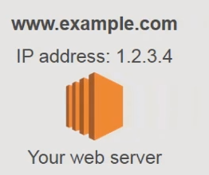

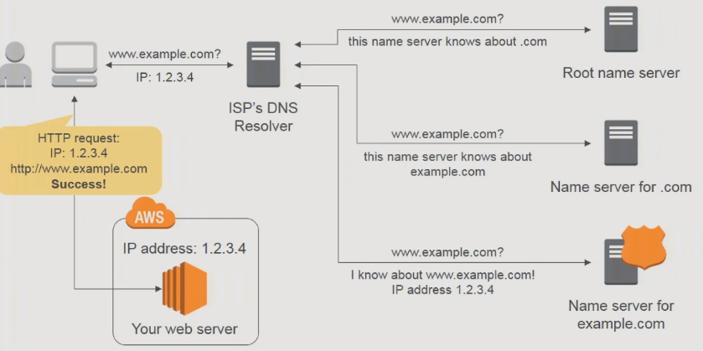 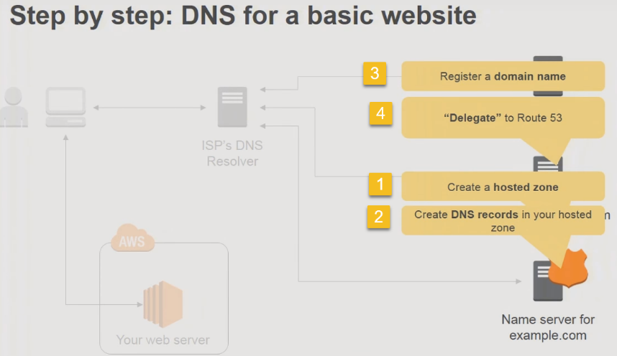

Configuring Amazon Route 53 DNS for Your Heroku App

**Table of Contents**

* [Prerequisites](https://devcenter.heroku.com/articles/route-53#prerequisites)
* [Overview](https://devcenter.heroku.com/articles/route-53#overview)
* [Hosted zone](https://devcenter.heroku.com/articles/route-53#hosted-zone)
* [CNAME records](https://devcenter.heroku.com/articles/route-53#cname-records)
* [Naked/root domain](https://devcenter.heroku.com/articles/route-53#naked-root-domain)
* [Activate Route 53](https://devcenter.heroku.com/articles/route-53#activate-route-53)

The [Domain Name System (DNS)](http://en.wikipedia.org/wiki/Domain_Name_System) is the internet’s routing layer responsible for mapping human-readable domain names (e.g., www.heroku.com) into machine addressable IP addresses (e.g., 23.21.47.33).

Amazon AWS’s DNS service is called [Route 53](http://aws.amazon.com/route53/) and is a highly available and scalable service. For users with existing AWS infrastructure components it may be convenient to use Route 53 as your DNS provider.

This guide will walk you through the steps of setting up your Heroku app’s DNS configuration on Route 53.

[**Prerequisites**](https://devcenter.heroku.com/articles/route-53#prerequisites)

Before configuring your app’s DNS make sure you’ve used the Heroku CLI to attach your domain name to the application. This is necessary, in addition to the third-party DNS changes, to properly route traffic for specific domains to the right application on Heroku.

If you have not done so yet, attach the correct domain(s) to your app:

$ heroku domains:add example.com

$ heroku domains:add www.example.com

Be sure to specify all domains your application will serve, including subdomains.

[**Overview**](https://devcenter.heroku.com/articles/route-53#overview)

As with any DNS provider, configuring your Heroku app’s DNS involves the following steps:

1. Create a CNAME record to map from www.example.com to example.herokuapp.com or your [SSL endpoint](https://devcenter.heroku.com/articles/ssl-endpoint) if using SSL.
2. Establish a redirect from the root domain example.com to www.example.com to avoid the [risks associated with root domains and A-records](https://devcenter.heroku.com/articles/apex-domains).
3. Set Route 53 servers as the nameservers for your domain.

Route 53 uses different terms than standard industry parlance so this guide has non-trivial variance from other guides.

[**Hosted zone**](https://devcenter.heroku.com/articles/route-53#hosted-zone)

A hosted zone is Route 53’s term for the collection of DNS records that make up a single domain’s configuration. You will need to create a hosted zone for each domain you wish to configure on Route 53.

Sign into the [AWS management console](https://console.aws.amazon.com/console/home?) and select the [Route 53](https://console.aws.amazon.com/route53/home) service. Click the **Create Hosted Zone** button and type the domain name you are configuring.

Use the root domain name for the hosted zone (e.g., example.com).

[**CNAME records**](https://devcenter.heroku.com/articles/route-53#cname-records)

New records, such as the www CNAME record, are added in Route 53 as Record Sets.

To create a record set:

1. Select the newly created hosted zone for your domain and click the **Go to Record Sets** button.
2. In the Record Sets view, click the **Create a Record Set** button.
3. The Create Record Set window opens. In the Name field, type the name www (such as, www.example.com). In the Type field, select the CNAME type. In the Value field, if you are not securing your app with SSL, type the app’s default Heroku domain in the value field. Your app’s Heroku domain is just the Heroku app name followed by .herokuapp.com.

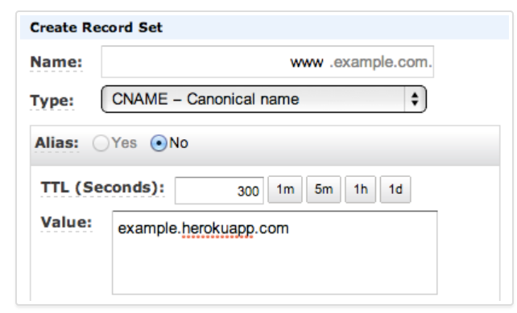

Otherwise, if you are using an [SSL endpoint](https://devcenter.heroku.com/articles/ssl-endpoint) to secure your app, type the your-endpoint-12345.herokussl.com endpoint URL in the Value field instead.

Use the heroku certs command to determine your SSL endpoint URL if you’re unsure of its value.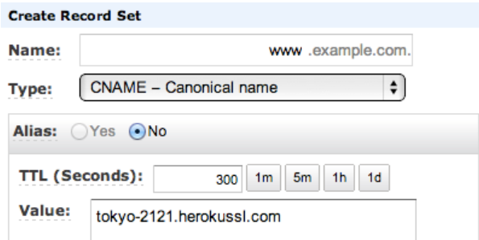

$ heroku certs

Endpoint Common Name(s) Expires Trusted

----------------------- ------------------- ----------------------- -------

tokyo-2121.herokussl.com www.example.com 2013-04-20 17:29:41 PDT True

Click the **Create Record Set** at the bottom of the form to save the www CNAME record mapping.

[**Naked/root domain**](https://devcenter.heroku.com/articles/route-53#naked-root-domain)

S3 won’t allow you to configure an SSL certificate, so you cannot easily use Route 53 to redirect your root domain in HTTPS. If you need to do this, consider using a DNS provider that offers CNAME/ALIAS records root domains. For more information see the [**Custom domains**](https://devcenter.heroku.com/articles/custom-domains#configuring-dns-for-root-domains)Dev Center article, or [**this blog post**](http://building.vts.com/blog/2015/11/02/route53-ssl-naked-domain-redirect/), which shows how to set up a SSL naked domain redirect.

Route 53 supports Alias records which use Amazon S3 static websites to dynamically resolve naked domains to their www counterparts using a 301 redirect. For example, example.com to www.example.com.

Go to your [AWS management console](https://console.aws.amazon.com/console/home), then open your S3 management console.

In order for the following bucket to appear when creating an Alias record in Route 53, you must name the bucket the exact same as the hosted zone. For example, if the hosted zone isexample.com then the bucket is named example.com.

Select the newly created bucket, but don’t open it. Click the Properties tab and open the “Static Website Hosting” section.

Click “Redirect all requests to another host name” and you will see that www.example.com is pre-filled. If it isn’t, type www.example.com.

Save the redirect settings, then open your Route 53 hosted zone for example.com.

Create a new record set. Leave the name blank. Select A type. Set alias to Yes and select example.com from the S3 Website Endpoints section of the Alias Target dropdown.

Create the record set.

Your domain example.com now redirects to www.example.com in a scalable way. Using Route 53 and Amazon S3 you’ve set up a naked domain which resolves to your Heroku app.

[**Activate Route 53**](https://devcenter.heroku.com/articles/route-53#activate-route-53)

At this point you’ve established the correct DNS configuration but no requests are using it. In order for Route 53 DNS to become active for your application you need to tell your domain registrar (GoDaddy, DNSimple, NameCheap, 1&1 etc…) to use your hosted zone’s Route 53 nameservers.

Go back to the Hosted Zones list and select your new hosted zone. There is a pre-populated *Delegation Set* section in the sidebar. These are the nameservers you need to provide your domain registrar for Route 53 to resolve your app domain.

Refer to your registrar’s instructions for updating the nameservers.

Supply this *Delegation Set* to your registrar to activate Route 53 for your application. It can take up to 48 hours for nameservers to become fully active.

1.)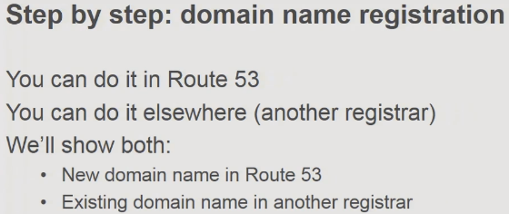 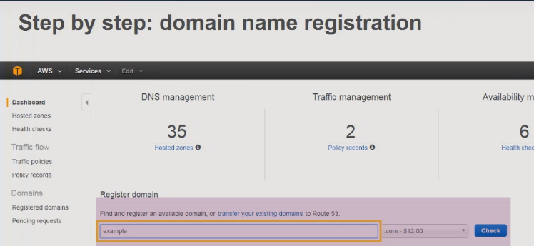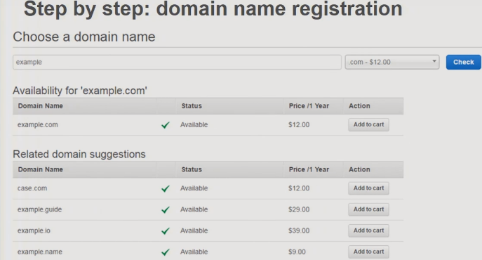 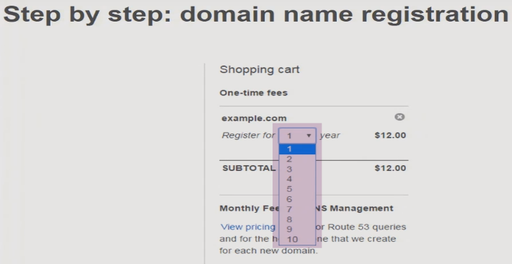 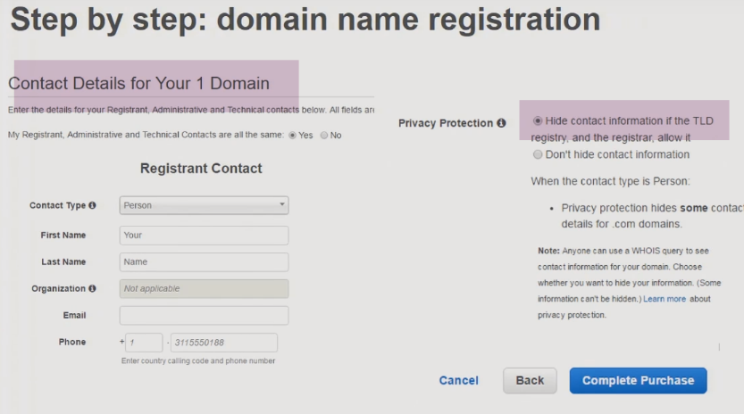

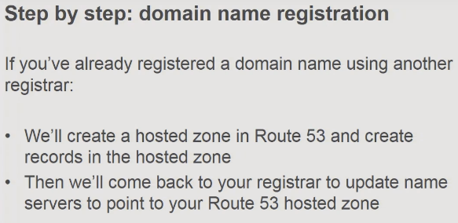

2.) 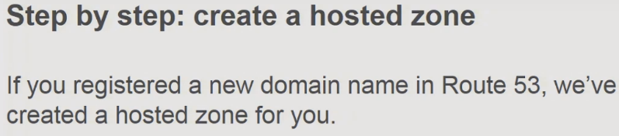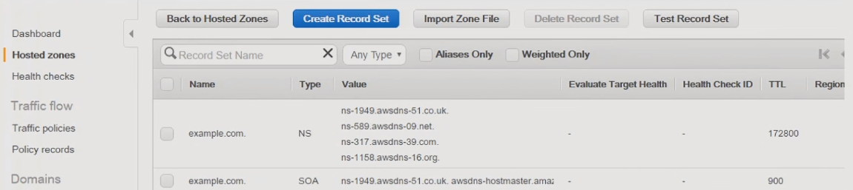 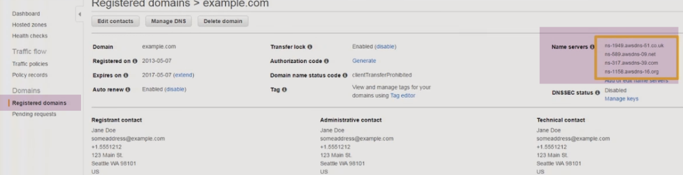

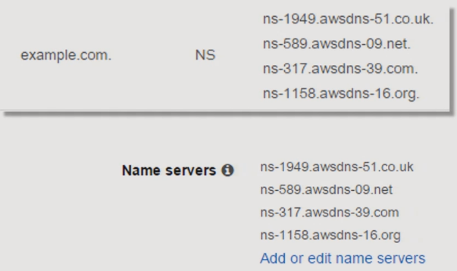

These NameServers will be serving your DomainName..

(IF HOSTED USING OTHER REGISTARS)…DO BELOW STEPS:

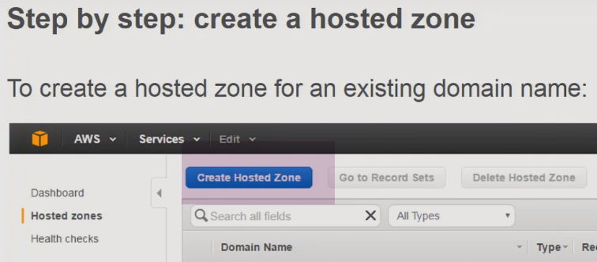 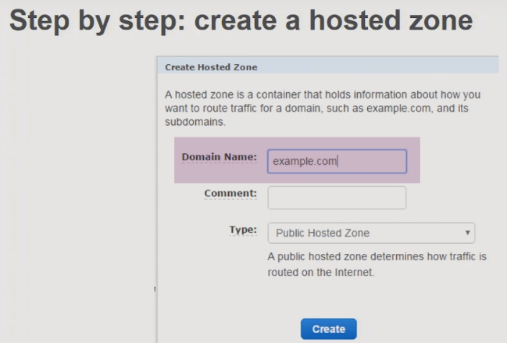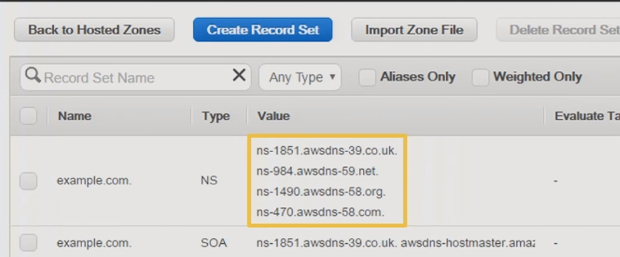

3.)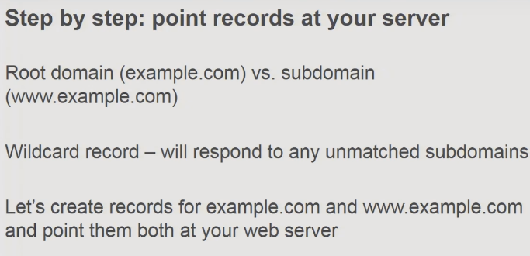 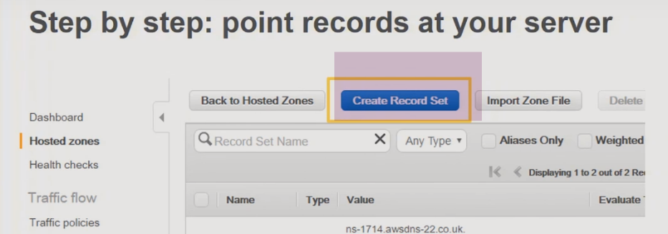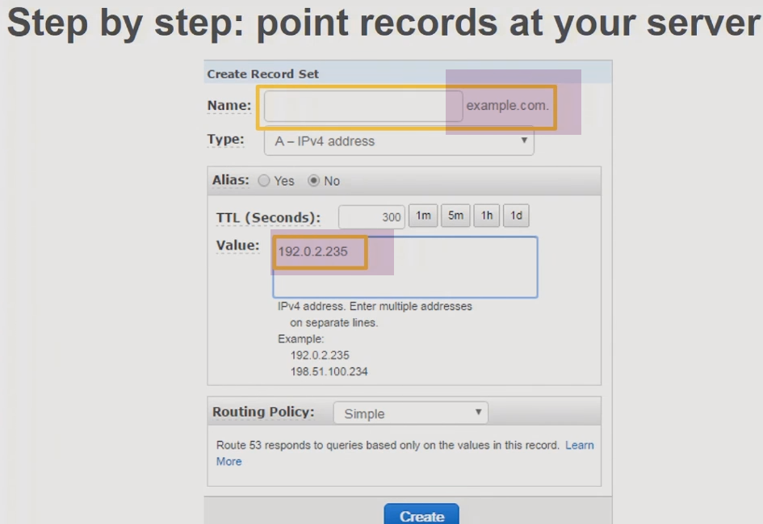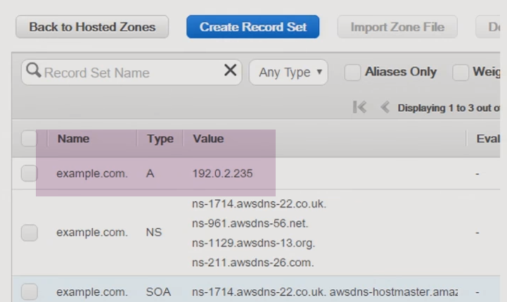

b.) 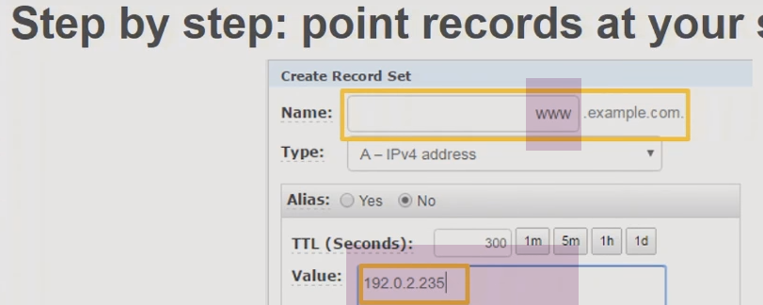

We can use different IP also

c.) 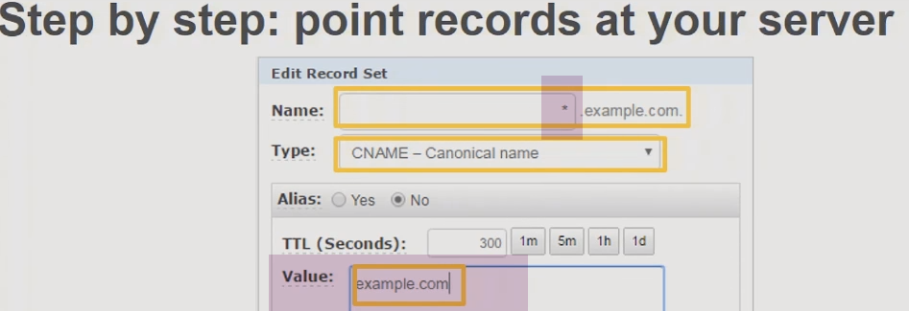

(wildcard)

When users use *.example.com, Users will get IP address of (VALUE)example.com

CNAME-🡪ROOT

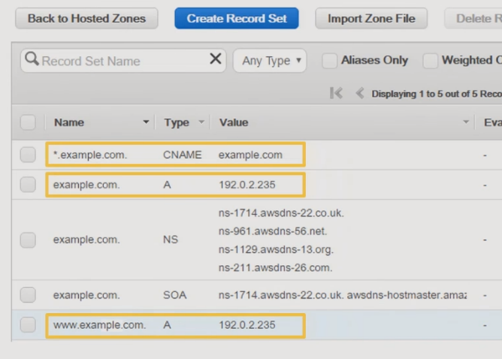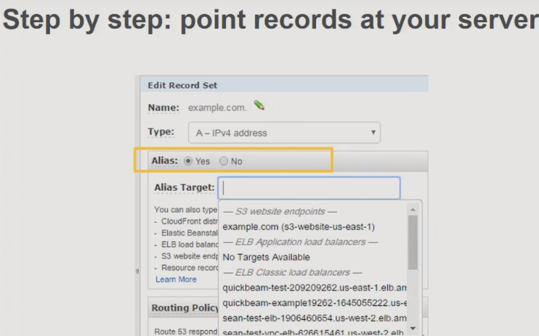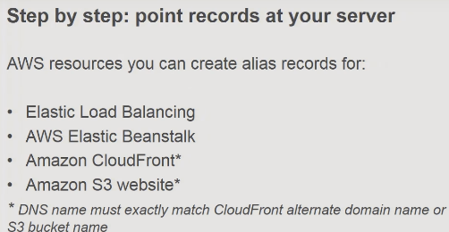

4,.) 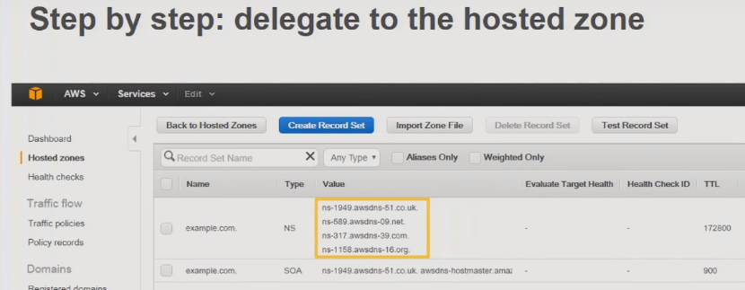

Already Doneyoutube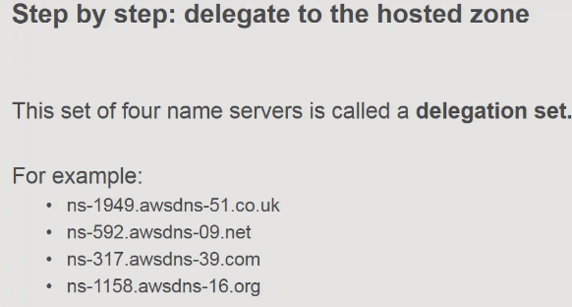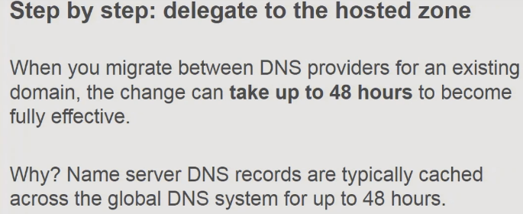

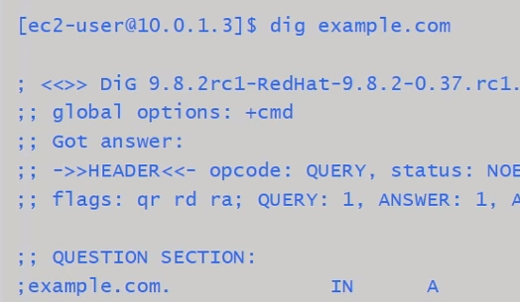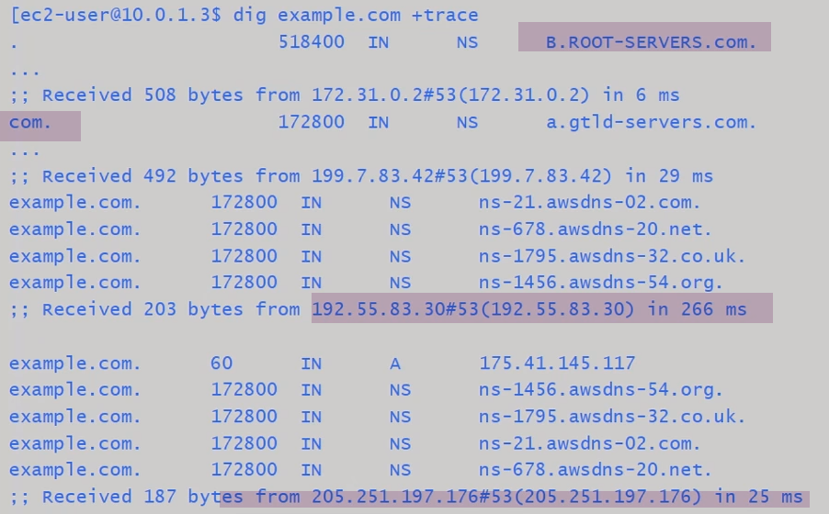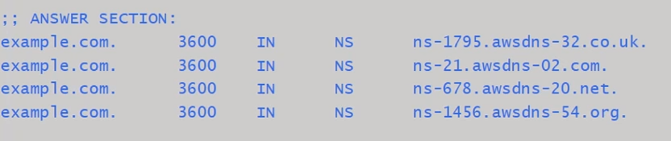

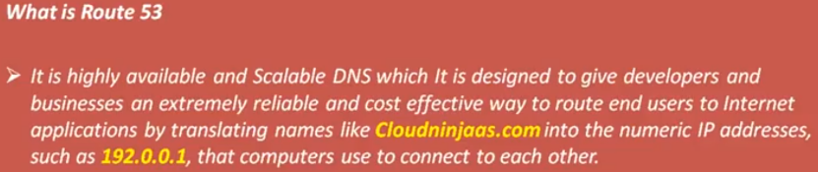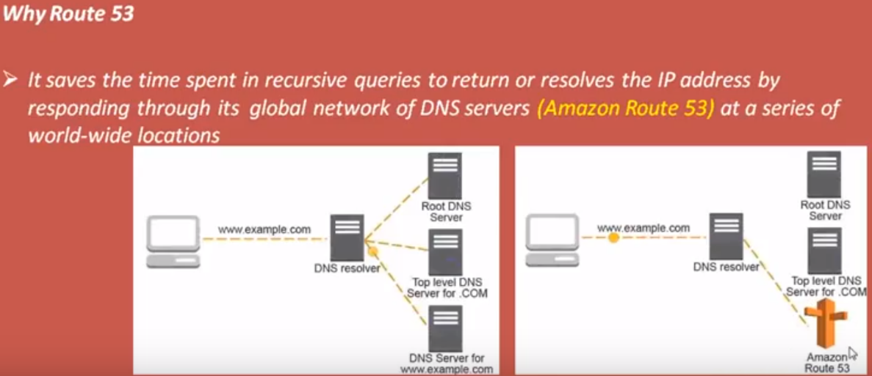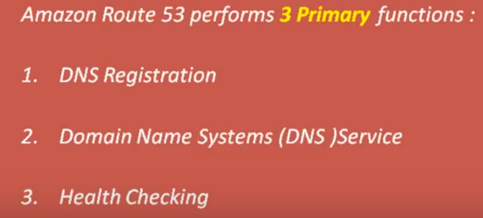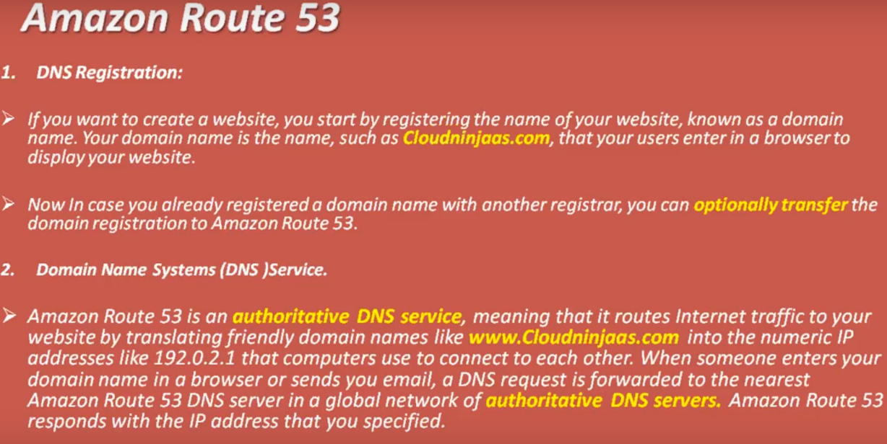

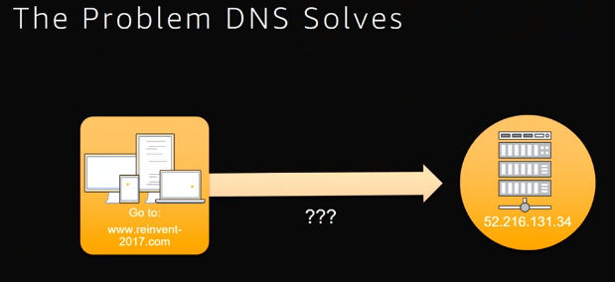 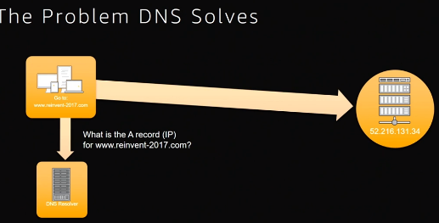

In order to connect to a service online you probably know the name you probably don't know the IP address and we need some way to find out what the IP address is the way we solve it is the DNS resolver. there's thousands of them across the internet.

As a service owner when you are building a web service you need to make sure that all of those DNS resolvers .

How do the resolvers answer the question ???

they talk to the authoritative servers and the authoritative servers are arranged in a kind of a tree so initially the roots own everything every name in principle is owned by the roots and

what the roots do is to say well this is too much traffic set up some separate name service for com And delegate to them not some more name name servers for an org and we'll delegate to them and they in turn delegate further down ..

**The tree is distributed and management of it is distributed not everybody wants to run their own DNS servers so this is one of the reasons I read 53 exists ..**

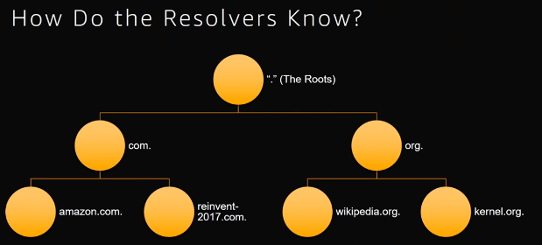

what a DNS resolver actually fundamentally has to do is to know where the root servers are..

It will start at the top query the roots and basically all of the right information that's needed from there can be caught can be got by querying down through the tree …

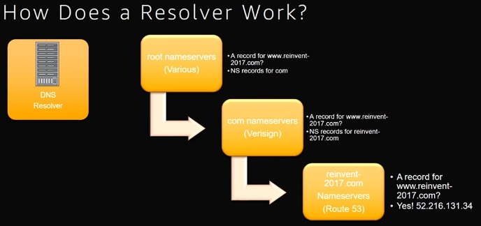

tool called Digg and it will give you a trace which shows you exactly how the resolution path goes

1. first step is we know what the root name servers are and we choose one which on this occasion is M root and
2. we query it for www re-invent 2017 comm and we get back no I don't have that talk to one of the comm name servers…
3. you must use L arbitrarily when you ask the L root server for WWWE invent 2017 com regretting that name already and the

what you'll get back is a further set of delegations to say oh that songs on these red 53 servers and so you query those red 53 servers and you get back an answer and **one thing that's interesting to point out here is you also get back the NS records this happens at every delegation**

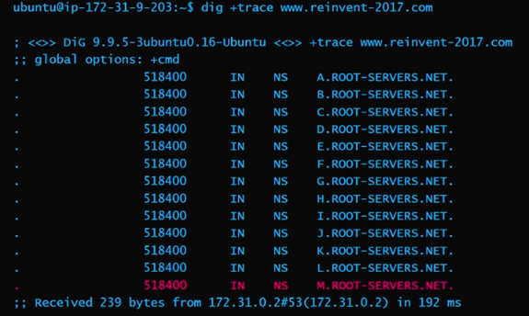 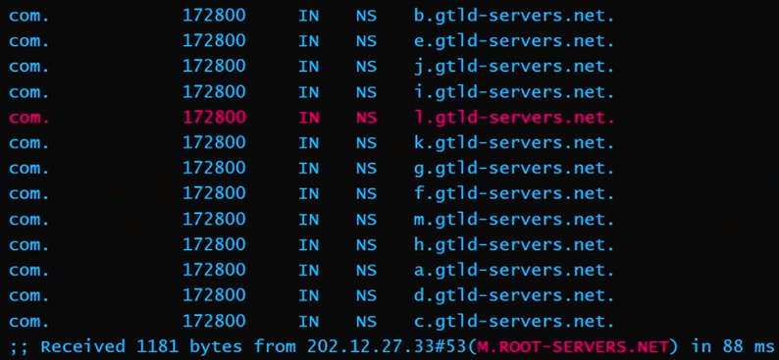

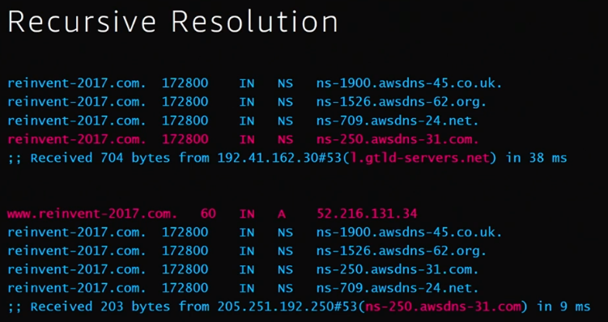

If you want a set of web service we have to create our zone the pink one there and we have to attach it to the tree..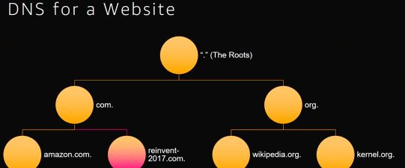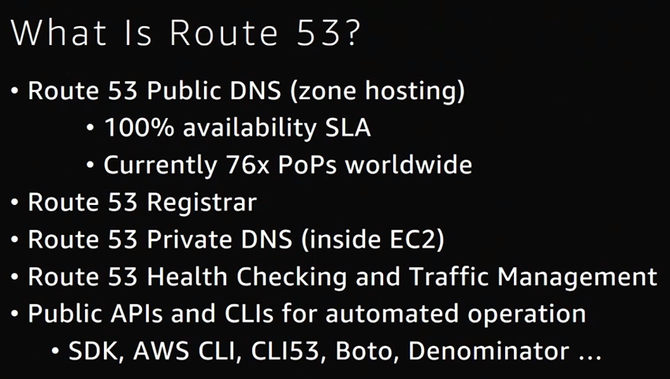

When you want to attach to the tree 🡪route 53 **registrar** is there

Registrar's allow you to book a name and set up a delegation in in whatever the TLD zone is comm

**private DNS as a service:** if you've ever managed an on-premises network you probably wanted to set up a whole lot of internal only DNS names that's a common enough practice and it's common also in ec2 VP C's so what private DNS allows you is basically the ability to do that.

**health checking service and traffic management**

**we want to register our domain**:

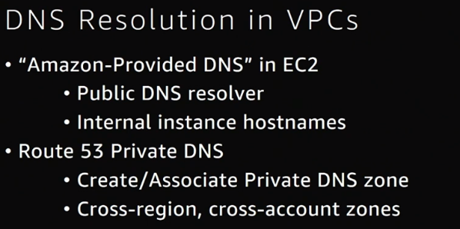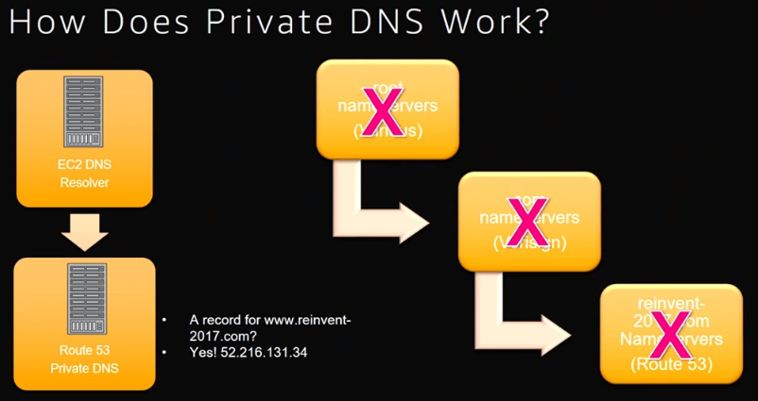

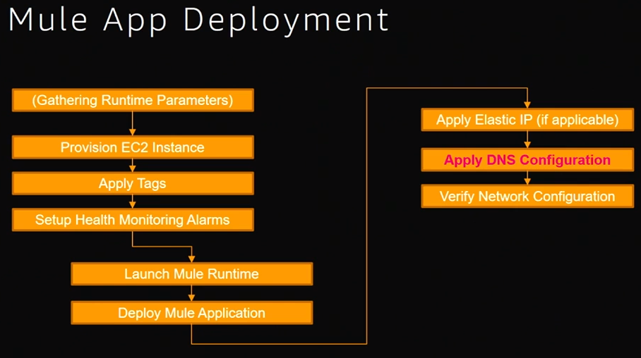

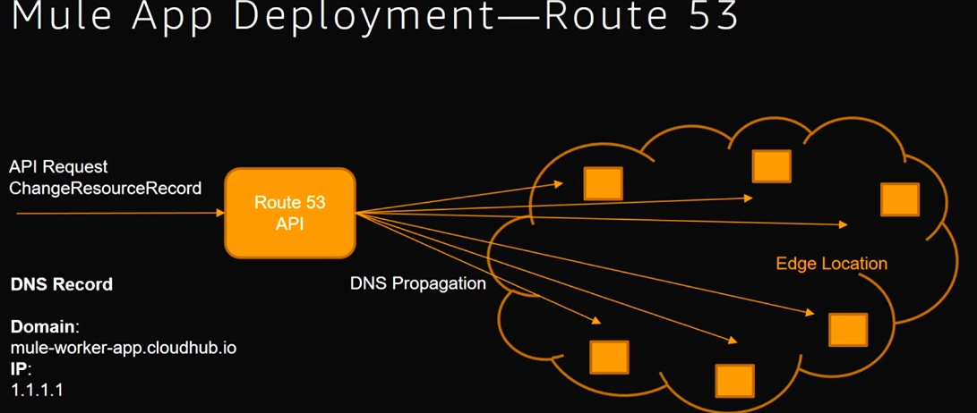

**ROUTE 53**

Route 53 is DNS service provided by Amazon.

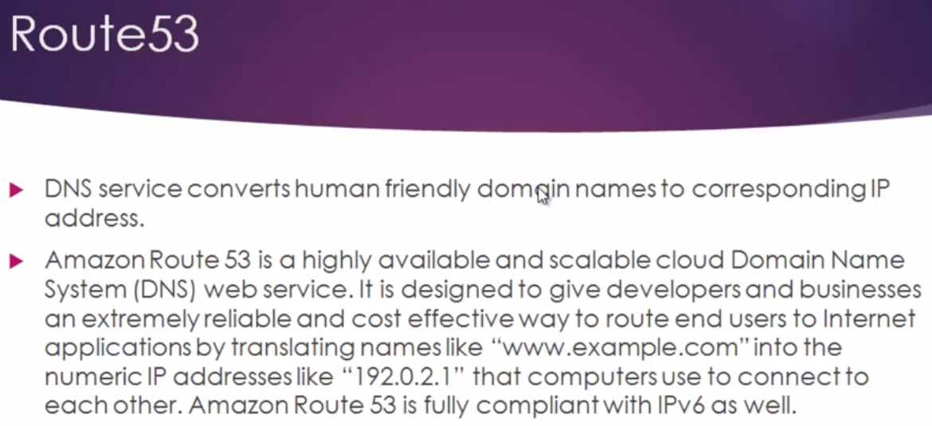

When we want to access [www.google.com](http://www.google.com), we are opening browser and entering this url. This is Human friendly Domain name(google.com).DNS will take this name and translate it into corresponding IP address. It makes sure my request is reaching web server or web application.

**Why Route 53 name???**

UDP and TCP services are using port 53.So they named it.

Route 53 resembles Route 66 of USA. It’s used to handle web traffic. SO they came up with standard name Route 53.

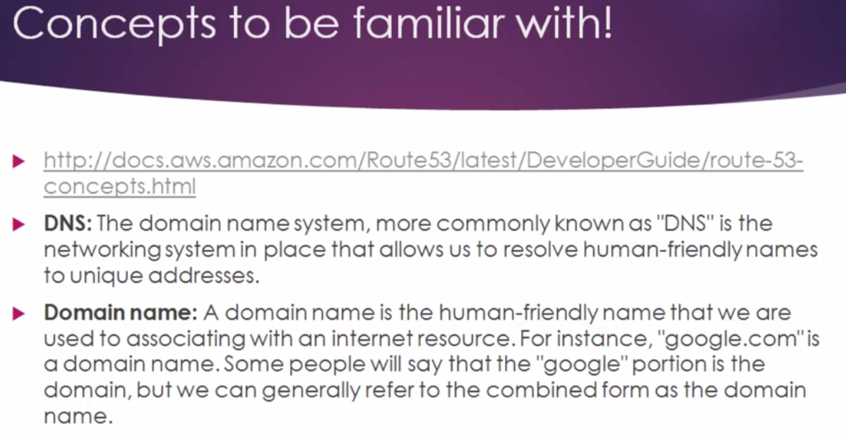

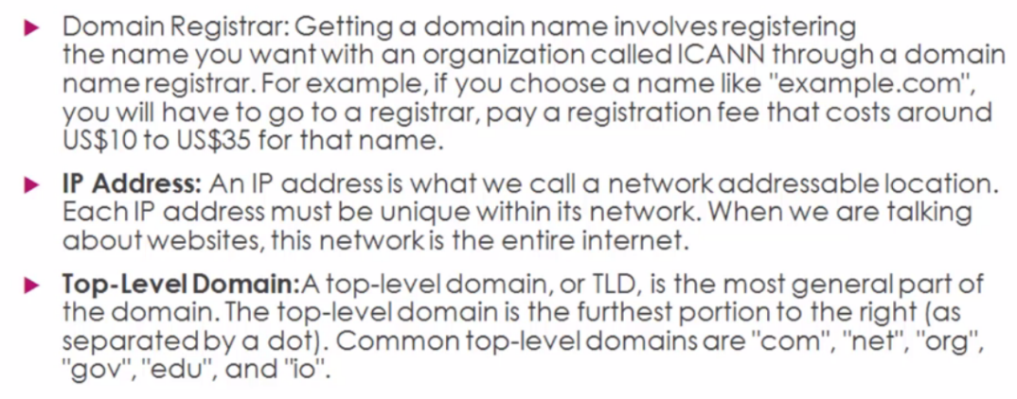

Domain names must be Unique. Otherwise it is pointless. So Domain registrars are authorities who will be registering Domain names.

Getting a Domian name involves registering name you want with Organization called ICAN through a Domain Name registrar.

For ex: If we want to choose a name called example.com, you will have to go to register, Pay fee (around 10$) .With Domain register we can register DomainNames of your choice.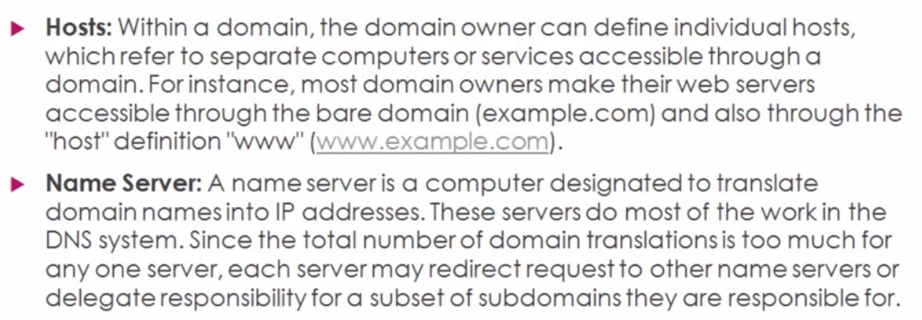

Hosts: The moment you try to access [www.google.com](http://www.google.com) request will be routed to that particular host..

NameServer: It’s not single server. It’s a set of servers who have delete access and They will be having Delegate access. They will be interconnected and sub-servers like that…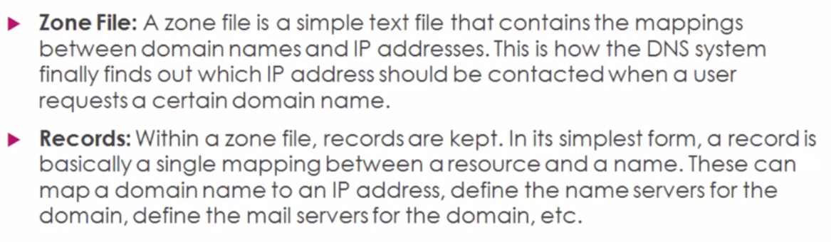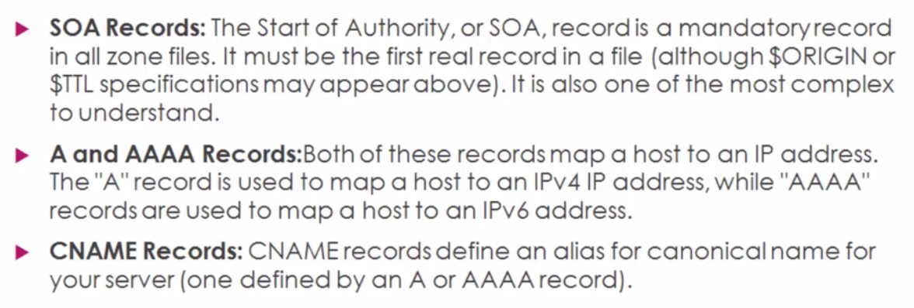

CNAME: Canonical Name records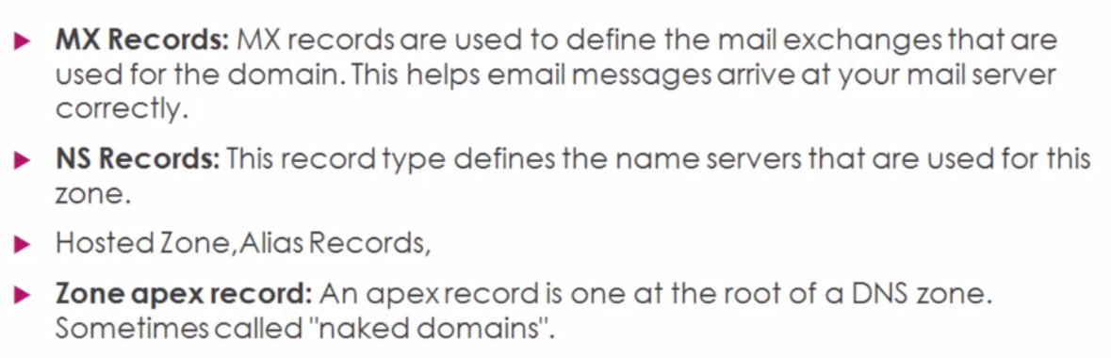

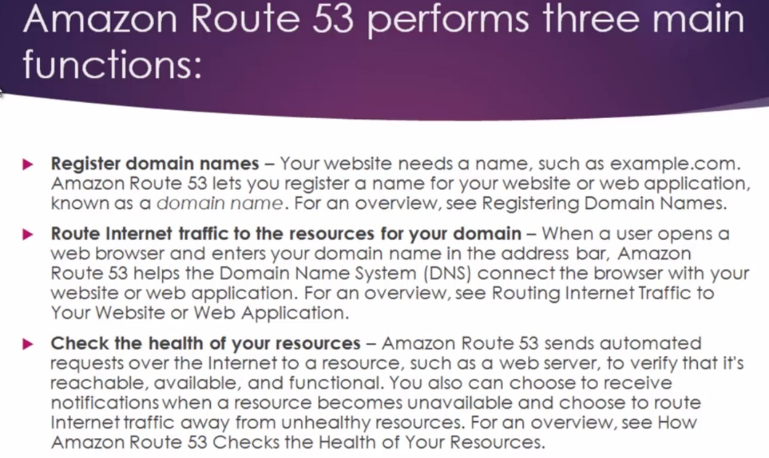

Amazon is Domain register. It’s helps to register a unique name for your website Ex: Example.com

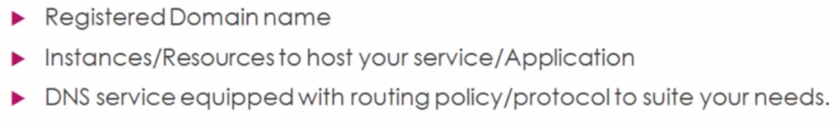

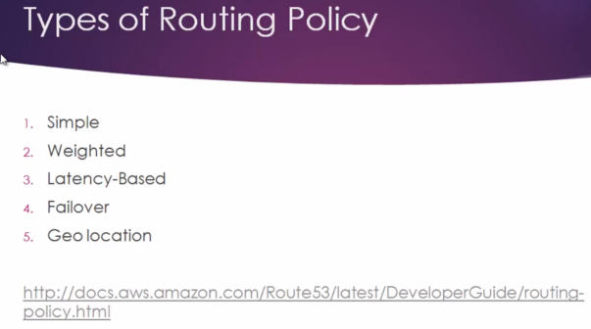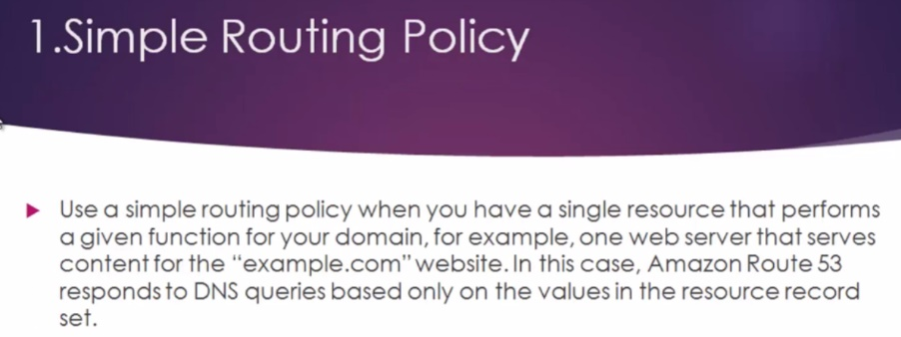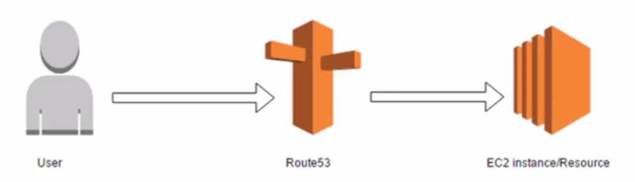

**When a user makes a request to access particular DomainName,Amazon Route 53 will be in action. It will convert example.com to corresponding IP address which is hosted in EC2 isnatnce.It will directly redirect to it. We are talking about Single instance.. As name says simple**

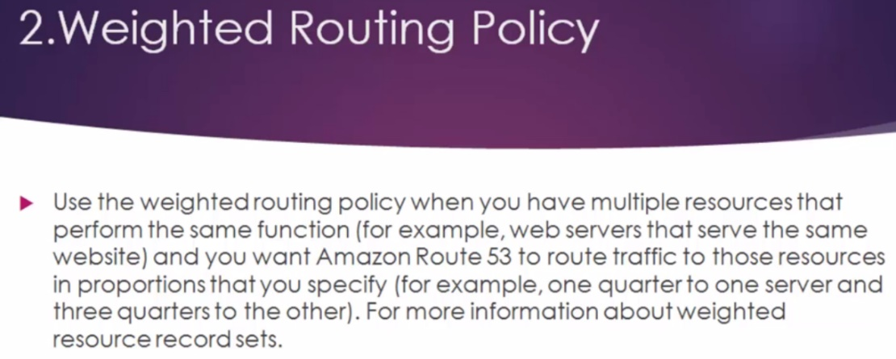

As name says, we will be employing weight to route traffic. Use weight routed policy, when we have multiple resources that performs same functions.

**Ex; Webservers that serve same website, and we want Route 53 to route traffic to those resources in proportions that you specify.. Ex: 60% of traffic needs to routed to single instance and then 40% to other instance .**

**We can do that scenario and handle it with weighted routing policy.** 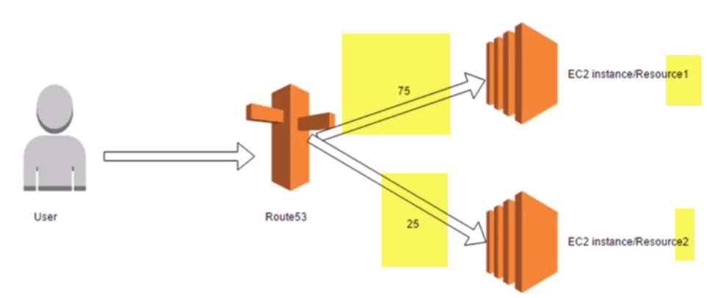

User makes request to access your website and Route 53 will takes DNS, and it will convert to corresponding IP address. It will consider weight that you provided, And based on weight it, it will decide to what instance I route Traffic to .. In Diagram : Most traffic is handled by 1st instance(75%) and 25% 2nd one.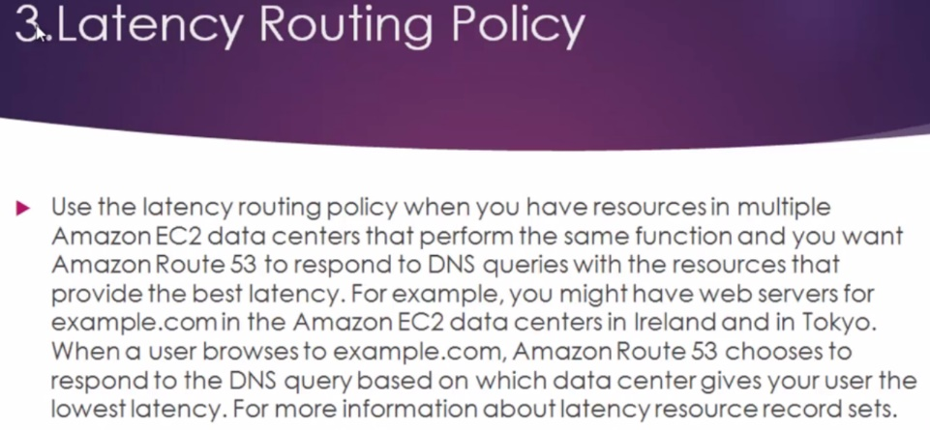

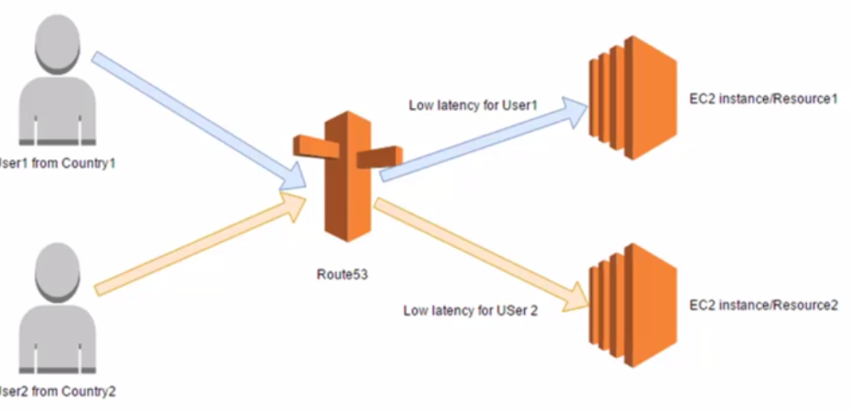

When we have resource in MULTIPLE Data CENTERS..that performs same function.And we want Amazon route 53 to respond to DNS queries with resource that provides Best Latency....

**Here Focus is on latency..Need to make sure user is getting Best Latency.**

**User1 is from Contry1, User2 is from Contry2.Route 53 will decide user1, if I route to resource 1..Latency will be very less.And it will be gonna be best for User-1.So traffic will be routed to near by country or near by instance..**

**Same with user-2: Route 53 will decide, what instance will give best latency for user-2.Traffic will be routed to That instance.**

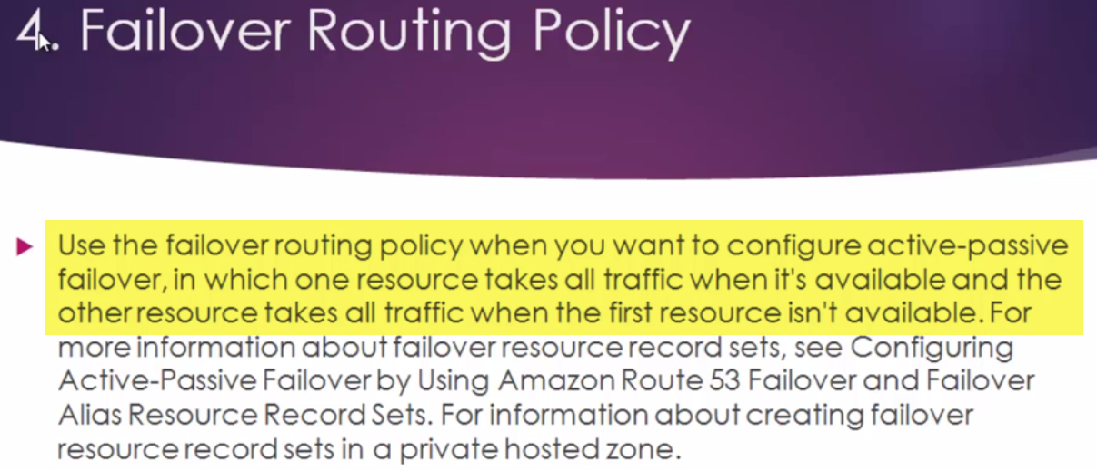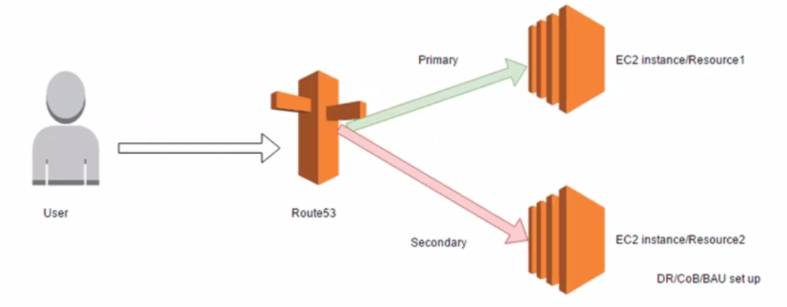

Here user makes a request to access your website. Amazon Route 53 will take DNS entry and translates into corresponding IP address.

Here, we have primary instance serving all the traffic…If that goes down. Secondary instance will comes into action..2nd instance will be active.. And all traffic from Route 53 will be re-direct to that particular instance.

**If something happens to Primary and it goes down.. Secondary(backup instance) will be Up and running..**

**We call it DR(Disaster recovery) or Business Continuity Plan(BCP) or BAS( Business Asusual Setup)**

Every organization will maintain, this kind of environment for their production or live Environment..

There ill be backup or secondary instance which will comes into action, when Primary goes down.  
So, Route 53, we can configure this primary and secondary ..And if something happens to Primary Amazon health checkup will check it.., and redirect al traffic to secondary instance.. AND USER WILL HAVE NO OUTAGE…

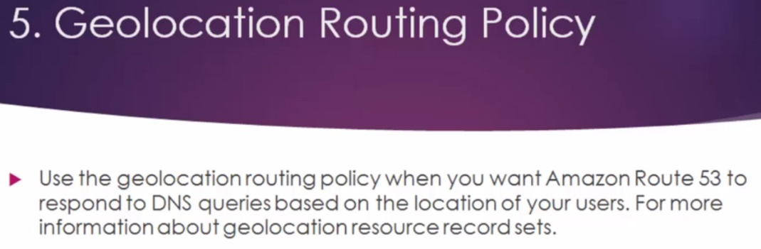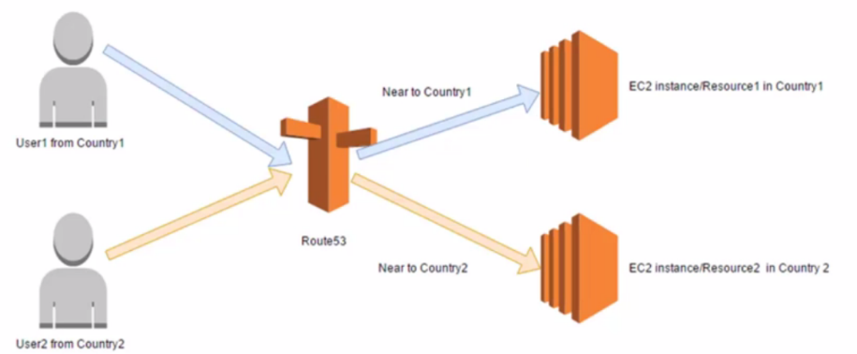

**LAB**

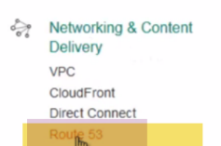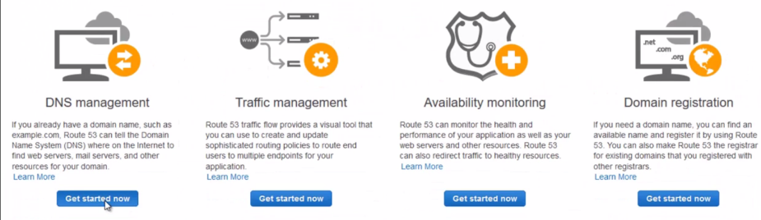

1. **DNS MANAGEMENT**

We are going to Register our own Domain name. Amazon is domain registrar now. 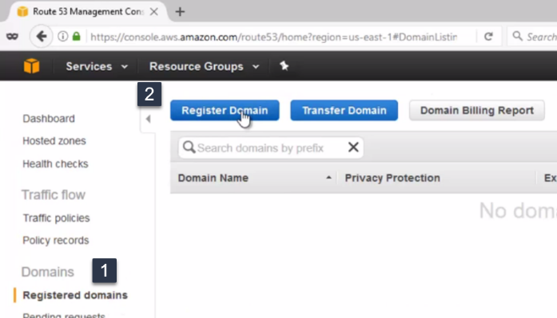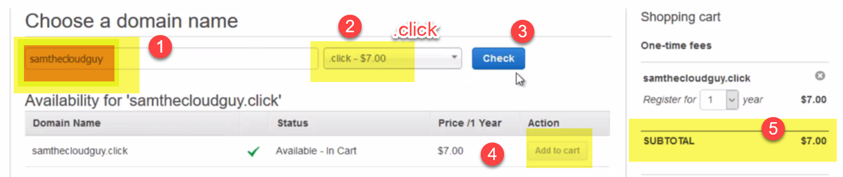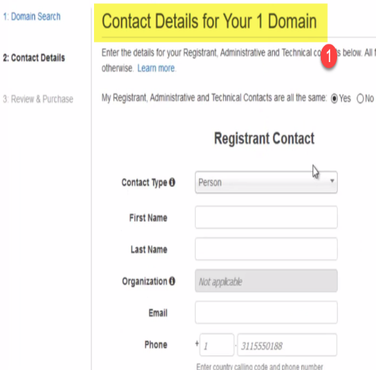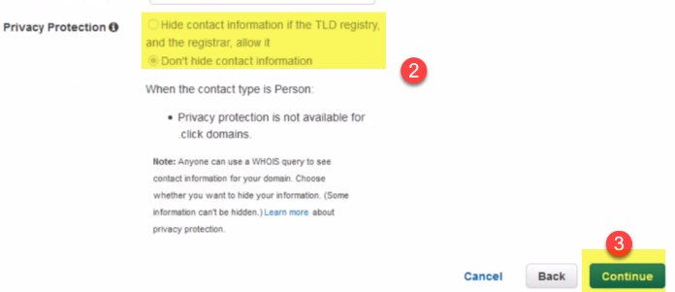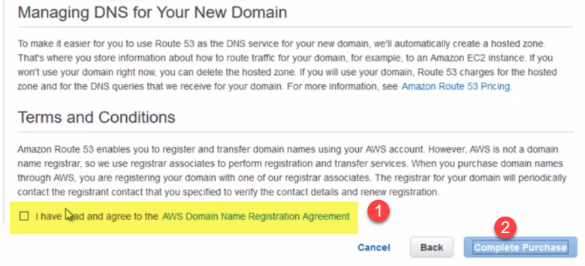

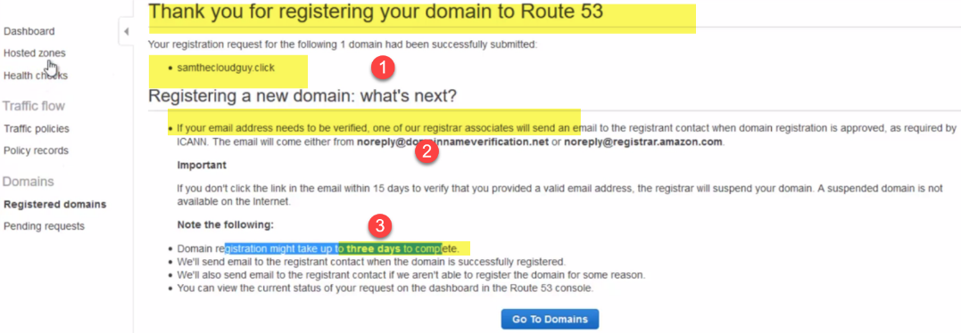

**To Check Status:-🡪 Dashboard🡪Alerts**

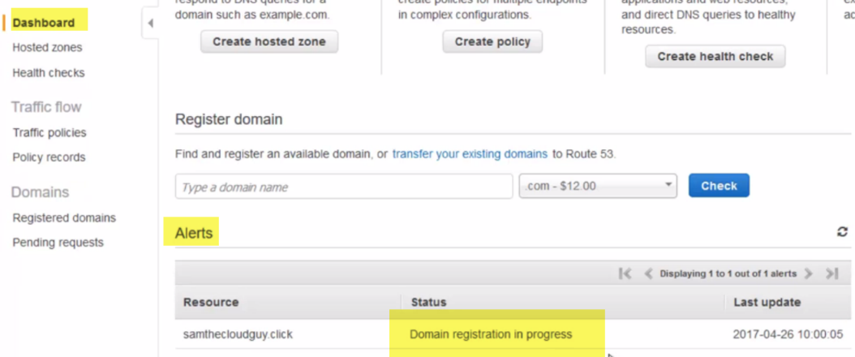

**We must make payment to complete registration.**

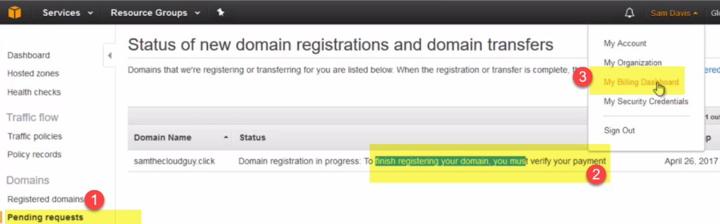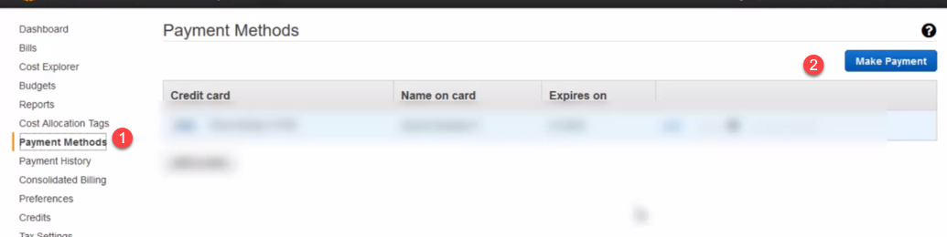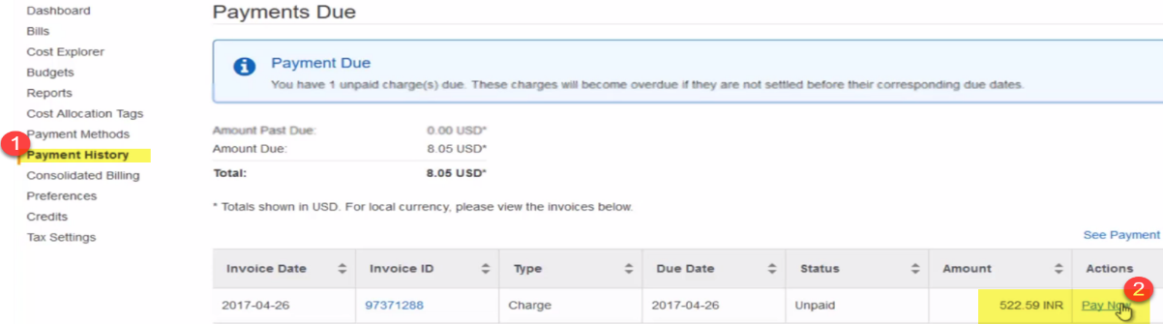



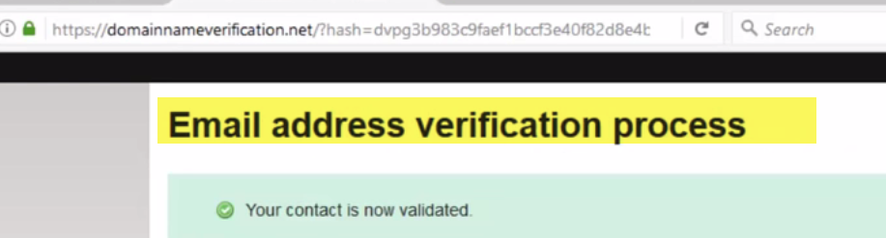

**Email also verified now…Now Domain is ready..**

**Verify: a.) Dashboard🡪Alerts**

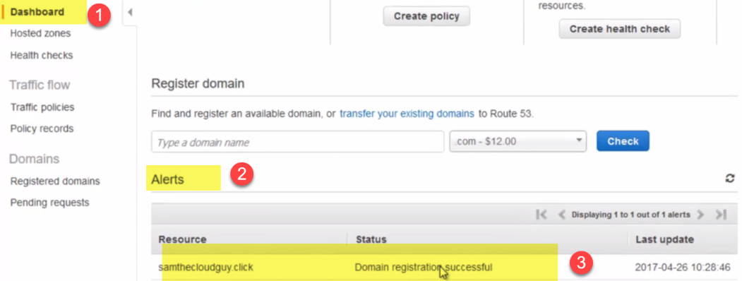

b.) No Pending requests

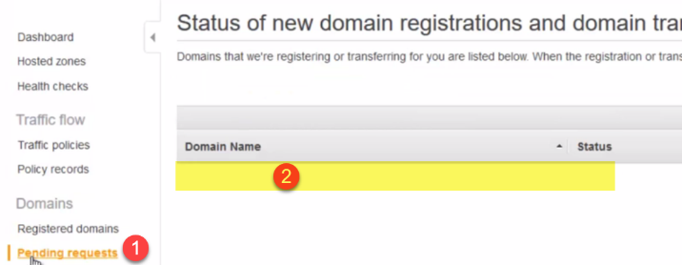

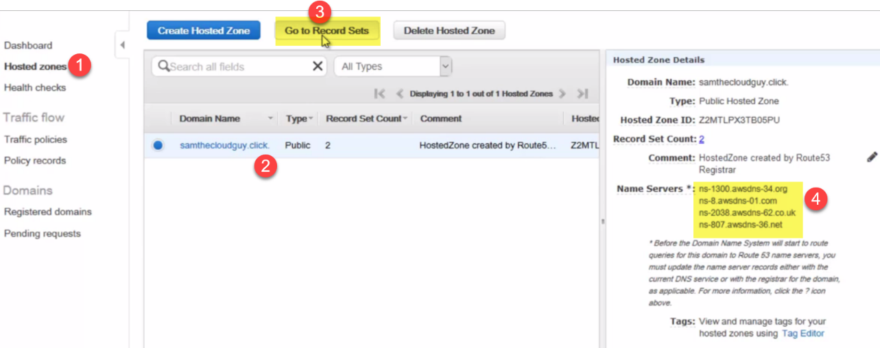

**Now go to Hosted Zones, click on registered domain, and then go to Record Sets** 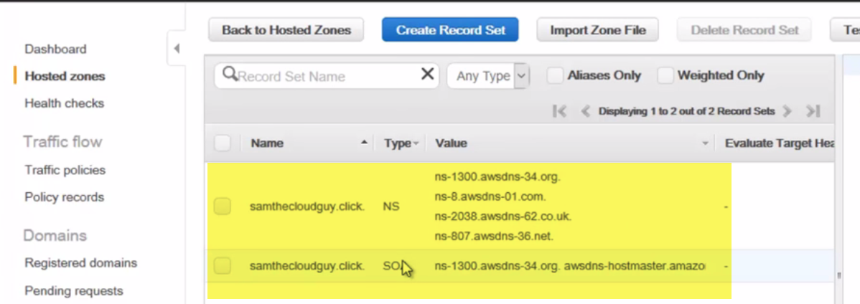

These are 2 records that got created, that got created during domain registration.

NS:

SOA: Start of Authority record..

**LAB**

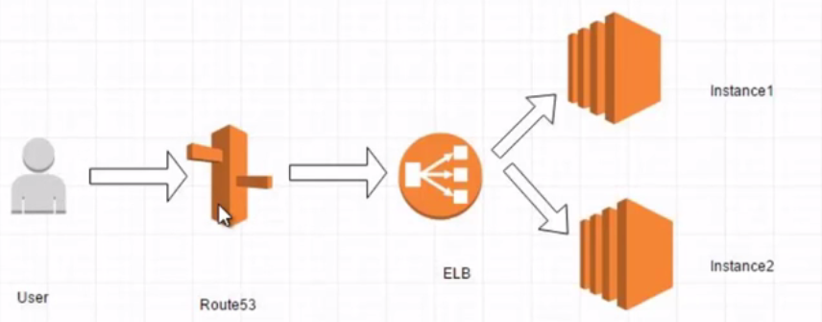

Whenever user click samthecloudguy.click, route53 will come into picture, and it will re-direct trafiic to ELB.

Behing ELB, we have 2 instances, that holds our webpage..

1. Lets create **2 instances.(instance1, instance2)**

**Bootscript**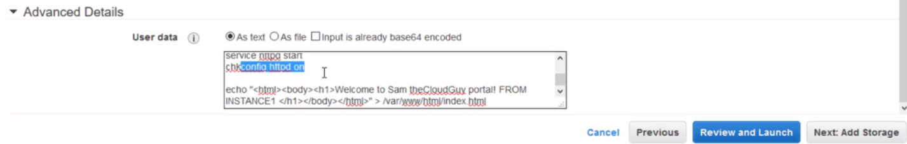

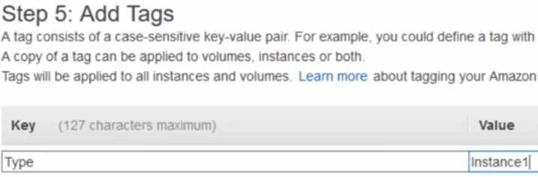

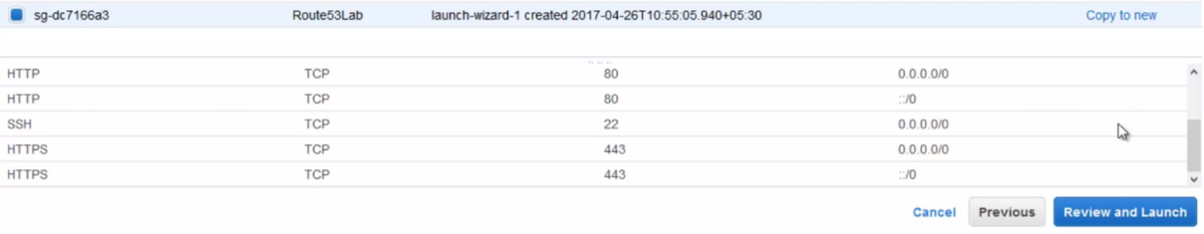

**Same Security group for both EC2 instances**

**2.)**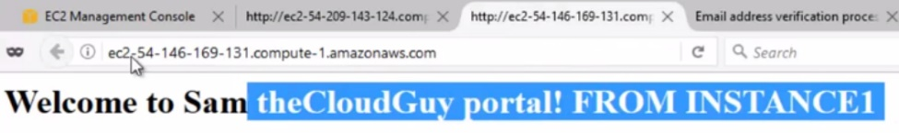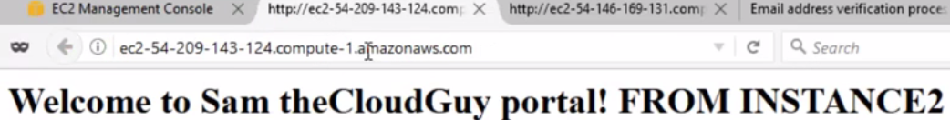

**3.) Create ELB.**

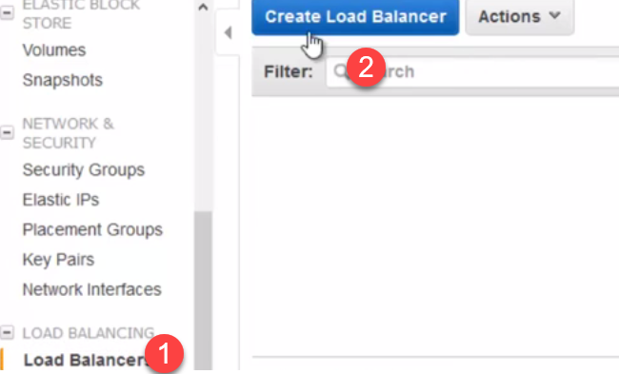 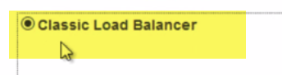

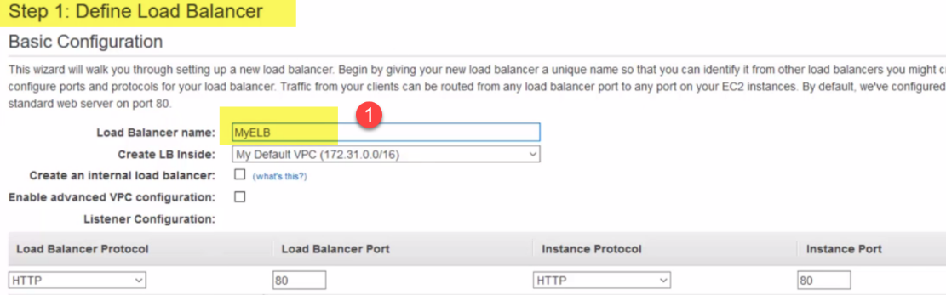

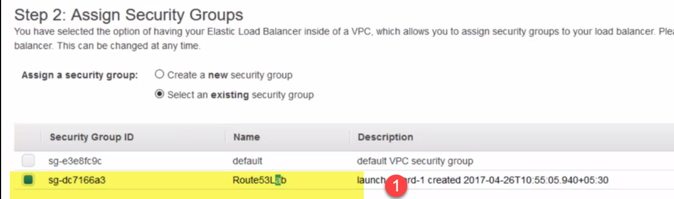

This is Security Group, selected for EC2 instances…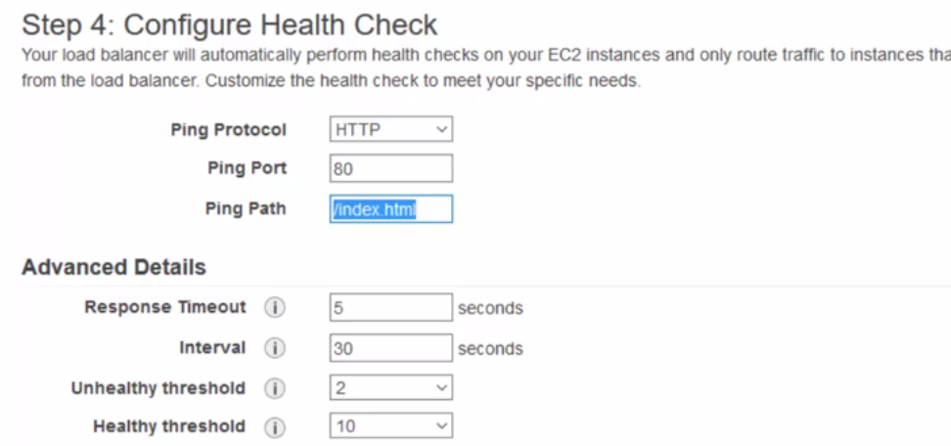

(leave as it is)

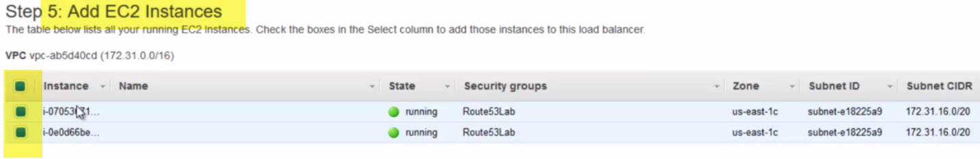

Add EC2 instances to ELB

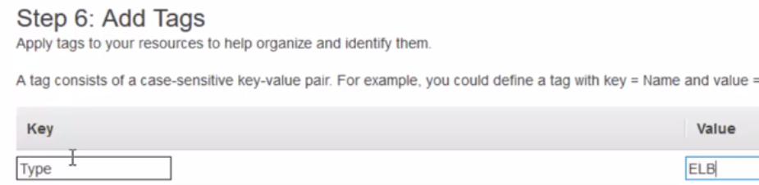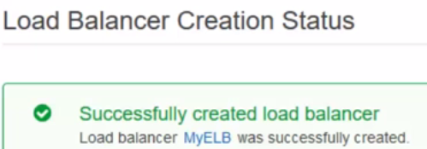

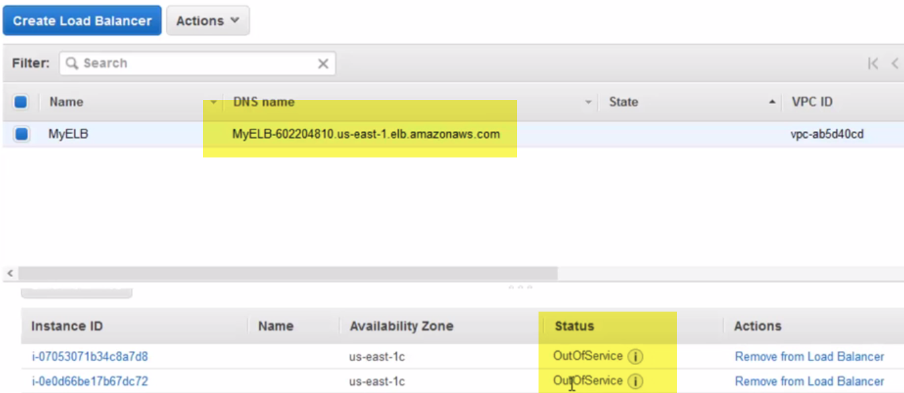

Wait for sometime, until ELB figures Both CE2 instances and find index.html file.

ELB: 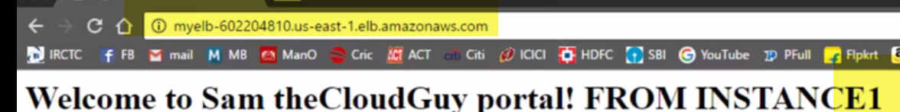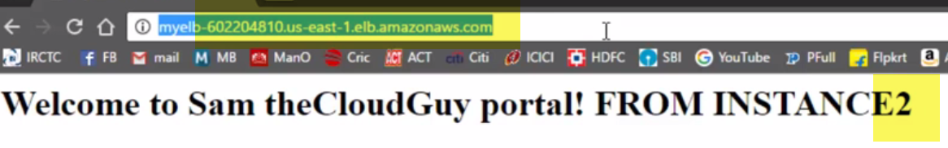

Traffic is routed evenly to instance1 and 2.

**Lab-2: Lets implement this setup 1 Ec2 instance in Mumbai region..**

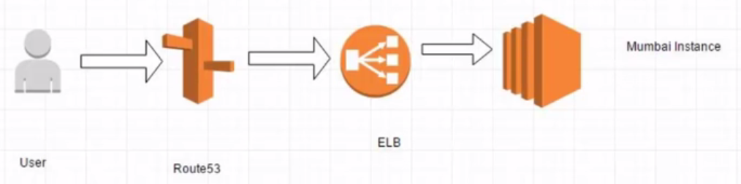

1. Launch instance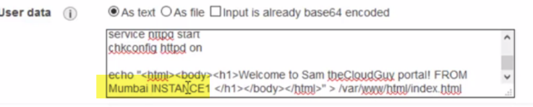
2. 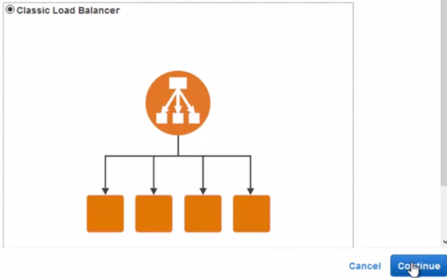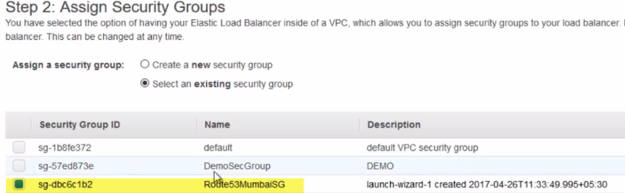

Same security group as EC2

1. IP Address of EC2: 



(from ELB) 

**Goto Hosted Zone**

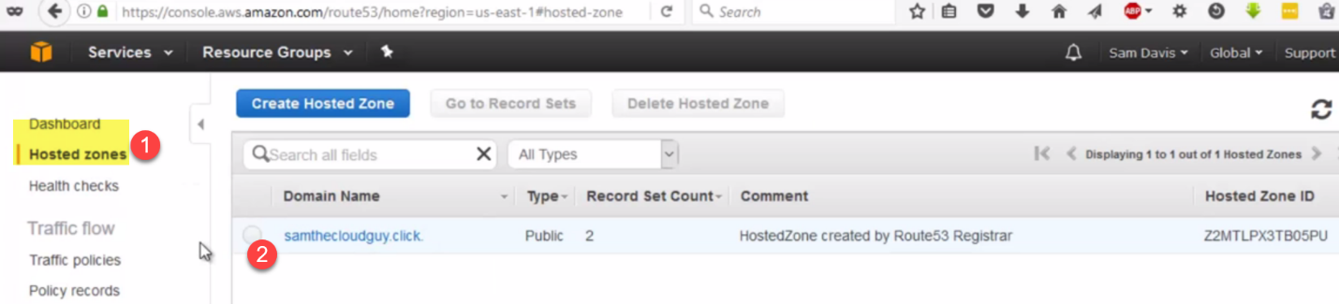

**Goto recordSets**

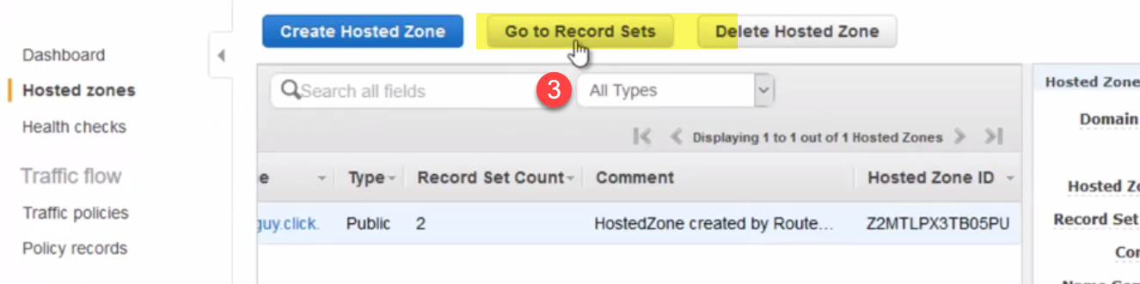

Samthecloudguy is the domainname registered..And I already have Recordsets created already.

**(NS record and SOA record)**

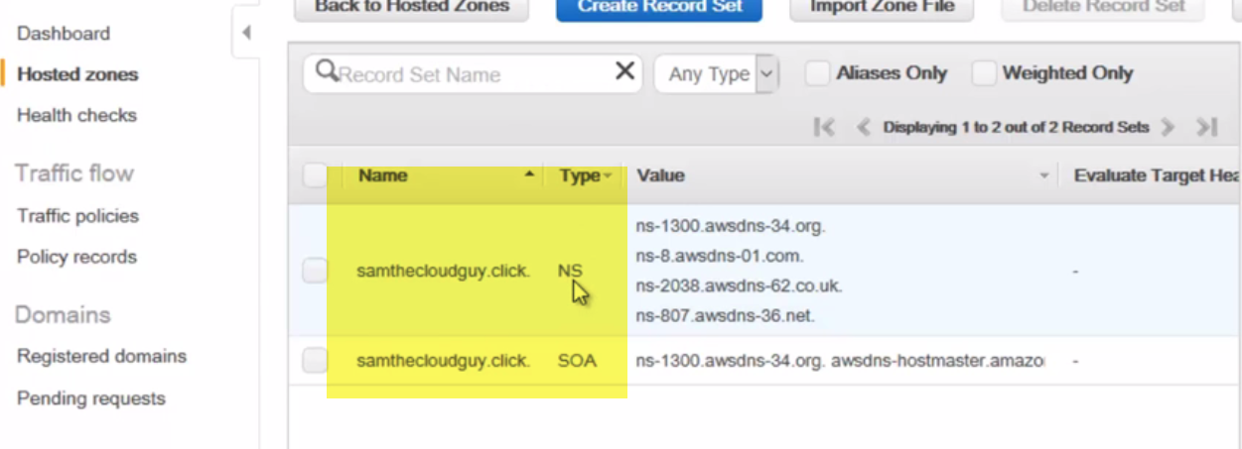

**Create New Record Set:**

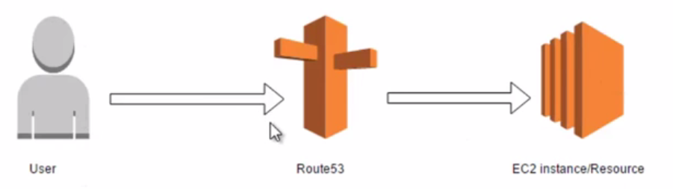

**We are going to implement Simple routing technique.. Whenever user wants to access apage, Route 53 will come into picture.., and redirect traffic to specific EC2 instance.**

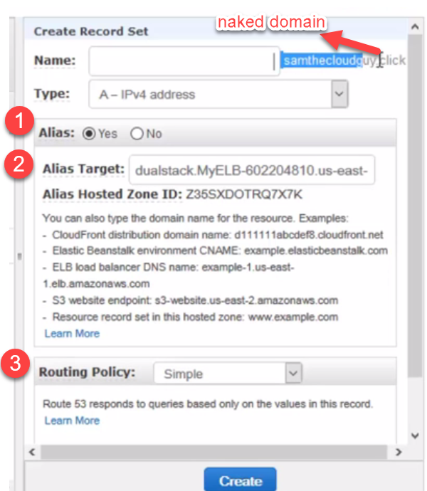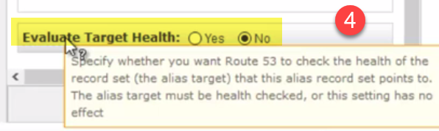

**Name:** In name section, we can type something like [www. We](http://www.We) can go with blank m which is called NAKED domain.

**Alias:** This is an alias record. So select it.

Alias: If you want this record to be an alias for AWS resource, please select this.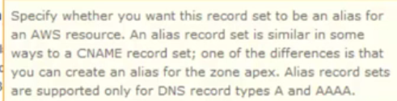

**Alias Target:**

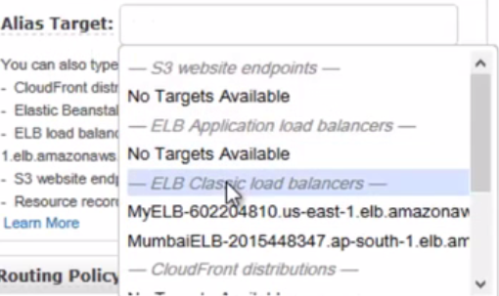

If you remember, we have different ELB, one in Mumbai region and 1 in Virgina.

all traffic.., when we hit this naked domain or alias Address.,it will route traffic to particular ELB.

**Routing Policy:**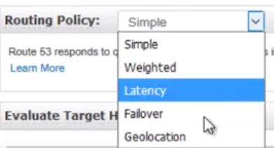

Here we have all 5 routing policies.We are going to stick with Simple.

**Evaluate Target Health:**

This gives option, where Route53 can check health of **record set…That this Alias Record set points to..**

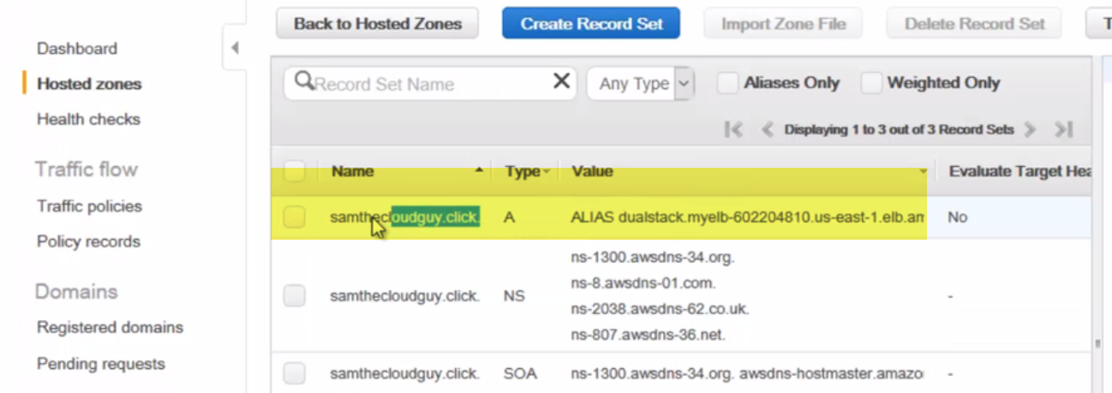

It will directly take me to this target, when we hit urll..

Use Naked domain samthecloudguy.click..

When we click url, traffic is routed to instance-2..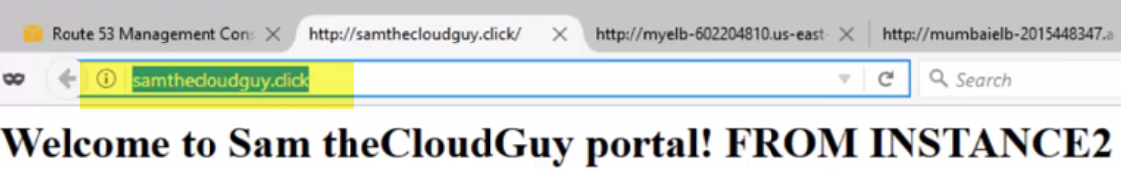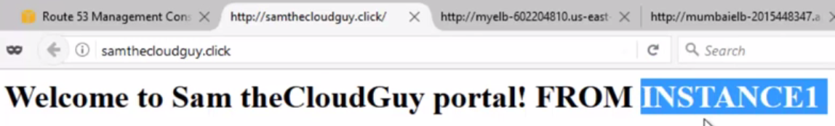

TheInstance1 is serving traffic..(SIMPLE ROUTING POLICY).

**In this case, we only have to select target ELB.. When I hit url,it will be redirecting to my ELB address.**

**Weighted**

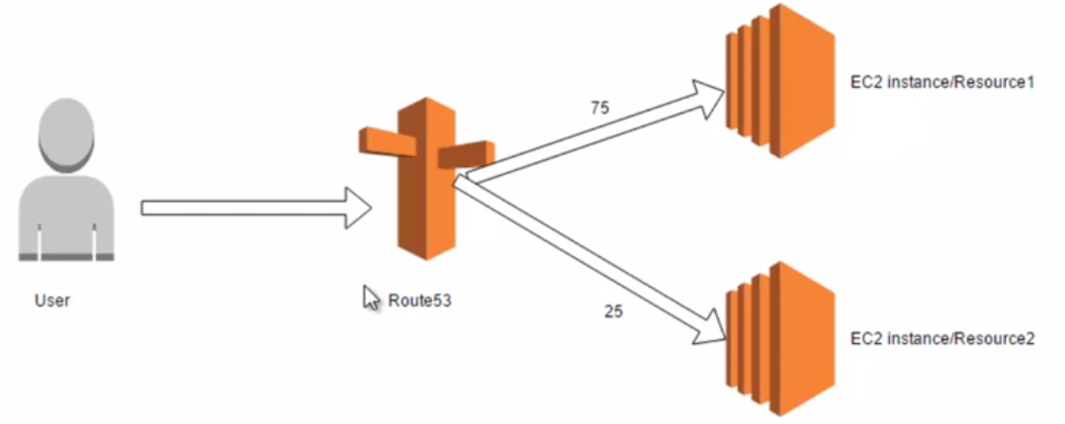

User will request for specific

We have multiple instance from multiple countries . ..Users from different countries trying to access your website ..Route 53 will take DNS and resolve to corresponding IP address.. Since, we have multiple instance, Route 53 will route to near by country instance..

If user is from Conyrt-1, and have instance running from same country-1 ..Traffic will be routed to same country-1 instance. ...And same is applicable to all users..

If user is from country-2, and we have instance running on same country..Traffic is gonna route to same instance..

(based on user geo-location, traffic will be routed)..

These are routing policies, by which we can improve overall performance of applications.

## **What AWS Route 53 brings to the DNS table**

Amazon Route 53 is a highly available and scalable DNS service offered by AWS. Like any DNS service, Route 53 handles domain registration and routes users’ Internet requests to your application – whether it’s hosted on AWS or elsewhere.

But Route 53 also intelligently directs traffic based on sophisticated routing policies and, through automated health checks, away from servers that might be failing.

Like many AWS services, Route 53 is a pay-as-you-go service. You will be charged for the number of hosted zones you create and maintain and by the number of requests routed.

In my previous post, I discussed some of the basics of [how DNS works](https://cloudacademy.com/blog/how-dns-works/).  Now we will explore the value that Route 53 can create for your domain needs and why and how you might want to migrate your domains over to Route 53.

**Why you should consider migrating to Route 53**

Once you’ve got your domain up and running, you can choose a routing policy that best fits your needs.

#### **Simple Routing Policy**

This is the most common and, as the name suggests, simplest routing type. If, say, your application server has a public IP address of 205.251.242.103, and you’d like to use the human readable address of amazon.com (assuming it’s available, of course), then you would use Route 53 to map amazon.com to your IP. From then on, any browser requests for amazon.com would be directed to 205.251.242.103.

#### **Weighted Routing Policy**

By assigning different numeric weights (or “priorities”) to multiple servers providing a web service, you can direct a higher or lower percentage of your incoming traffic to one particular server over another. This kind of routing can be useful for load balancing and testing new versions of a software package.

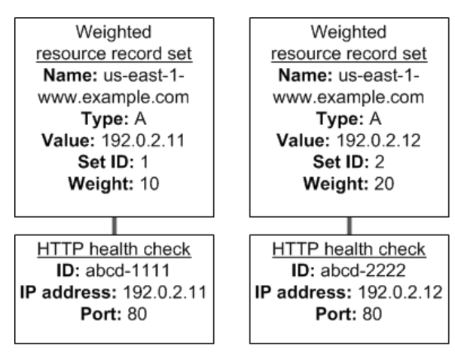

#### **Latency based Routing Policy**

A latency based policy directs traffic requests to the server that will be able to respond with the lowest possible latency (delay). You could, for instance, run your application in multiple AWS regions, and Route 53 will automatically route users to those that will deliver the quickest.

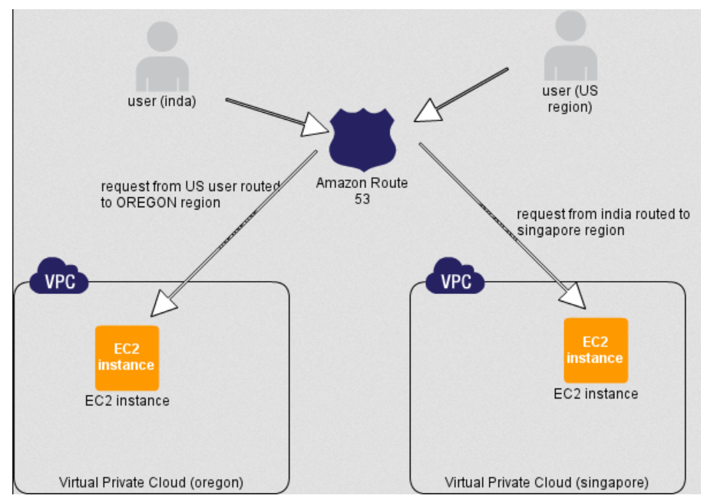

#### **Failover Routing Policy**

A failover policy will send all traffic to the server you set as primary for as long as that server is still healthy. If, however, health checks determine that it’s failing, traffic will be diverted to a designated backup resource.

#### 

#### **Geolocation Routing Policy**

This policy lets you designate resource targets based on your users’ geographic location. So, for example, you might want all queries from India to be routed to a server located in the same physical region in order to limit latency.

### **Some Route 53 features**

**Domain Registration.**You can purchase domains from all top level domains (.com, .net, .org, etc.) directly from route 53, avoiding the need to migrate altogether. Route 53 also provides privacy protection for your WHOIS record at no extra charge.

**Private DNS.**Private DNS records let you create private hosted zones and route traffic using easily managed domain names within your VPCs. This can, for instance, allow you to quickly switch between IP-based resources without the need to update multiple embedded links.

**Health Check.** Route 53 monitors the health  of your application and, when an outage is detected, redirects users to a healthy resource.

**AWS service integration.**Route 53 is tightly integrated with Elastic Load Balancing (ELB), CloudFront, and S3. You can easily route traffic to an ELB CNAME record, a static website hosted on S3, or generate custom domains for your CloudFront URLs.

**Alias Records.**Instead of an IP address, an alias resource record can, for instance, point directly to a CloudFront distribution, ELB load balancer, or Amazon S3 bucket. This way, even if the IP addresses of the underlying resources should change, traffic will still be sent to the correct endpoint.

### **Migration options**

1. **Leave your domain name with your own registrar**

If you would like to use Route 53’s routing features, but have no need to move your domain name from its current registrar, you simply need give your registrar the new name server addresses you’ll get from Route 53 upon creating a hosted zone. Once you have updated your name servers with your own providers, Route 53 will ensure the routing of all new domain requests through its own name servers.

1. **Migrate your domain name to Route 53**

When you decided to migrate, you will need get the DNS record data from your DNS provider. You will then import this data to a Route 53 hosted zone, and replace the registrar’s name server records with AWS name servers that you get by clicking on “GethostedZone”. Depending on your TTL settings, changes will take place within 24 to 48 hours.

-----------------------------------------------------------------------------------------------------------------------------------------------

You can send visitors to different servers based on country of their IP address using Amazon Route 53 cloud based dns server. For example, if you have a server in Amsterdam, a server in America, and a server in Singapore, then you can easily route traffic for visitors in Europe to the Amsterdam server, people in Asia go to the Singapore server and those in the rest of the world be served by the American server. This will results into the various kinds of benefits such as: **Better performance** as you are sending web site visitors to their nearest web server.

1. **Reduced load** on origin.
2. **Geomarketing**/online advertising.
3. **Restricting content** to those geolocated in specific countries (I am not a big fan of DRM).
4. In some cases you can get potentially **lower costs** and more.

In this post, I will explain how to configure and test GeoDNS using AWS Route 53 service

## Our sample setup

[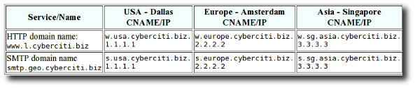](https://www.cyberciti.biz/topics/cloud-computing/aws/)Fig.01: Sample geodns setup for HTTP/SMTP service  
Please note that IPs (1.1.1.1) or CNAMEs (w.usa.cyberciti.biz) can be hosted by AWS or your own server anywhere in the world.

## AWS Route 53 routing policy

From the Route 53 documents:

If your application is hosted on Amazon EC2 instances in multiple EC2 regions, you can reduce latency for your end users by serving their requests from the EC2 region for which network latency is lowest. Route 53 latency-based routing lets you use DNS to route end-user requests to the EC2 region that will give your users the fastest response.

It is possible to use Route 53’s Latency Based Routing (LBR) feature with non-AWS endpoints or IP address. Route 53 don’t restrict what IPs or CNAMEs you can tag with a region. AWS dns server will route traffic to those IPs/CNAMEs “as if” those IPs or CNAMEs were hosted in whichever AWS region you choose to tag. The following is the current list of regions supported by Route 53 LBR:

1. Nothern Virginia, US: us-east-1
2. Nothern California, US: us-west-1
3. Oregon, US: us-west-2
4. Ireland, EU: eu-west-1
5. Singapore, Asia: ap-southeast-1
6. Tokyo, Asia: ap-northeast-1
7. Sydney, Asia: ap-southeast-2
8. Sao Paulo, South America: sa-east-1

## Configuration

First, open the Amazon Route 53 console at <https://console.aws.amazon.com/route53/> > Choose your existing domain > Click on the **Go to Record Sets** button > Click on the **Create Record Set** button.

### CNAME geodns settings for USA Dallas server

1. Set **Name** to www.l.
2. Choose **Type** to CNAME.
3. Set **TTL** to 30 seconds.
4. Set **Value** to w.usa.cyberciti.biz. seconds.
5. Set **Routing Policy** to Latency.
6. Set **Region** to us-west-1.
7. Set **ID** to Dallas, TX, Data Center.
8. Click the **Create Record set** button to save the changes.

[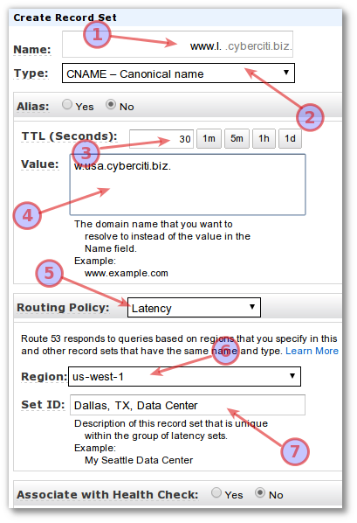](https://s0.cyberciti.org/images/faq/2013/04/aws.route53.geodns.1.png)Fig.02: CNAME geodns settings for Dallas/USA server.

### Set an IP address for CNAME w.usa.cyberciti.biz

Visit the Amazon Route 53 console at <https://console.aws.amazon.com/route53/> > Choose your existing domain > Click on the **Go to Record Sets** button > Click on the **Create Record Set** button.

1. Set **Name** to w.usa.
2. Set **Type** to A - IPv4 address.
3. Set **TTL** to 30 seconds.
4. Set **Value** to 1.1.1.1. Please replace IP address 1.1.1.1 with your actual AWS endpoint or any other valid public IP address in US.
5. Set **Routing Policy** to Simple.
6. Click the **Create Record set** button to save the changes.

[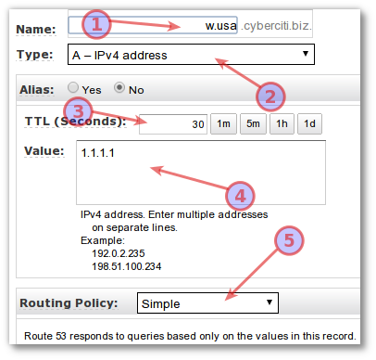](https://s0.cyberciti.org/images/faq/2013/04/aws.route53.geodns.cname-ip.png)

Fig.03: Set an IP address for CNAME w.usa.cyberciti.biz.

**Repeat this process**for the rest of your HTTP and SMTP services. At the end, your setup should look like as follows:

[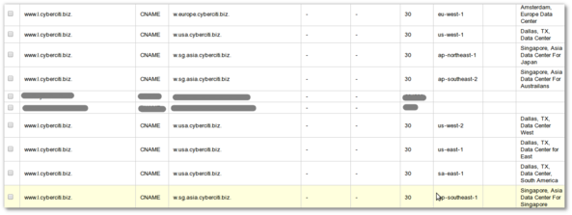](https://s0.cyberciti.org/images/faq/2013/04/aws.cname.large.png)Fig.04: Showing all CNAME and AWS geo mapping for each region (click to enlarge).

[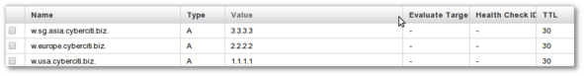](https://s0.cyberciti.org/images/faq/2013/04/aws.cnames-to-ip.png)Fig.05: IP address for all CNAMEs.

## Test it

Use the following [dig or host dns lookup command line utilities](https://www.cyberciti.biz/faq/unix-linux-dns-lookup-command/) to verify new settings:  
% dig +short www.l.cyberciti.biz.  
Sample outputs from various locations:

|  |
| --- |
| *## Asia ##*  w.sg.asia.cyberciti.biz.  3.3.3.3    *## Office in UK ##*  w.europe.cyberciti.biz.  2.2.2.2    *## IDC in US ##*  w.usa.cyberciti.biz.  1.1.1.1 |

The following images shows the accuracy of geo name-to-IP address resolutions around the world for

www.l.cyberciti.biz:

Fig.06: Route 53 geo location accuracy[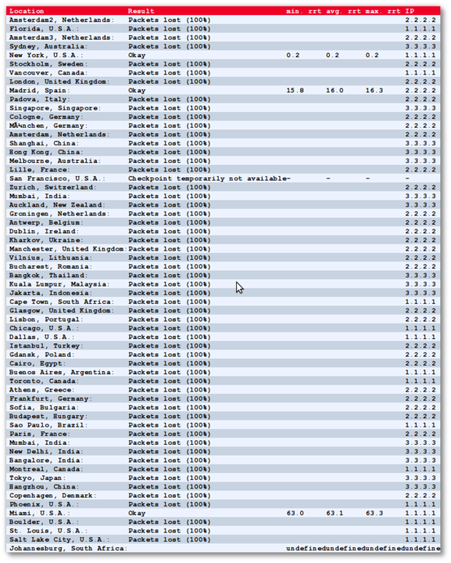](http://just-ping.com/index.php?vh=www.l.cyberciti.biz&c=&s=ping!)Limitations

Use of proxy servers, third party DNS servers other than your ISPs and VPN may give a false geo location to end-users.

Global Load Balancing Using AWS Route 53

An often under-appreciated service on AWS is Route 53. One could make the mistake of thinking of AWS Route 53 as just another DNS service. To the contrary, using [AWS Route 53](http://docs.aws.amazon.com/Route53/latest/DeveloperGuide/Welcome.html) for global load balancing, you can benefit from improved latency and better availability for your application stack.

What Is Load Balancing?

If you’re unfamiliar with load balancing or global load balancing, a quick explanation is in order.

Load balancing is a method of distributing application workload across multiple computing resources. This is typically done in a few different ways:

* **DNS.** With this method, a list of application endpoints is maintained in DNS, and client requests are distributed across your infrastructure by configuring policies that determine which end point is given during the DNS response. This can be done in a simple round robin fashion, or using AWS Route 53 Routing Policies.
* **Client side load balancing**. A list of application end points is maintained by a client application. The client then selects an end point to connect to based on logic programmed into the client.
* **Server side load balancing.** Clients connect to a load balancer, which then forwards requests to the application servers based on a list maintained on the load balancer.

Global load balancing involves routing application traffic to geographically diverse servers or data centers. This can be done with both physical and virtual infrastructure. We’ll be discussing using both DNS and server side load balancing using Route 53 and Elastic Load Balancing.

Load Balancing Use Cases

There are a number of use cases where you can benefit from global load balancing.

* Application latency. You might want to reduce application latency by locating your application servers in close geographic proximity to the application clients.
* Geolocation. Your requirements dictate that clients in a specific geographic region are routed to a subset of your application stack. This can come in handy when there are legal requirements dictating whether content is available to clients from that region, or where certain types of information (such as PII), are stored.
* Scalability. You want to spread your server footprint across multiple regions and datacenters as a means to scale your application. A use case for this would be one time events where you spin up datacenters in a region to handle traffic for a special event in that region, then spin them back down once the event is over.
* Application maintenance. You can reduce downtime in your application during maintenance cycles by shuffling traffic away from a regional installation while you perform updates or maintenance to that region’s servers, then moving the traffic back once your updates are complete.
* High availability can be achieved by distributing application load across your datacenters, and using monitoring to determine endpoint availability. Through the use of routing policies, you can have Route 53 automatically failover to a known good region if another region becomes unavailable for some reason.
* Disaster recovery could be achieved by maintaining a primary and a backup location. Data is replicated from the primary to the backup location, and if you are using Route 53 end point monitoring, failover from one region to another can be achieved in this manner.

Global Load Balancing Implementation

Say you want to set up virtual datacenters in multiple global AWS regions. While it is possible to globally load balance between both physical and virtual data centers, for the purposes of this discussion, our infrastructure will exist solely on AWS.

Regions

In this example, we will be using four different AWS regions to provide application availability to our clients. These regions are:

* US-West-1 (Northern California)
* US-East-1 (Northern Virginia)
* AsiaPacific-NorthEast-1 (Tokyo)
* EU-Central-1 (Frankfurt)

Using these regions will provide reasonable coverage for our theoretical globally located web clients. Naturally, you will need to assess where your clients are located for your own application implementation and which regions are best suited to serve them. You may only have US clients, in which case, US based AWS regions may be more appropriate than the global locations that have been chosen here.

Application Deployment

Plan and deploy your application stack in each location. Some things you will need to consider are redundancy, auto-scaling groups in each availability zone, AWS elastic load balancer deployment and cross-AZ load balancing, data replication between AZs and regions, VPC layout, connectivity between regions, application and instance monitoring, and your deployment and configuration management system.

As with everything on this list, be sure that you give careful consideration to your IP addressing scheme when connecting VPCs together. It is easy to overlook this when planning your deployment, and IP address conflicts could result if you simply use the default IP addressing in each VPC. This will make routing and network connectivity between regions difficult, if not impossible.

DNS Records

Our primary domain to be resolved by the web clients will be example.com. It is helpful to become familiar with [Route 53 routing policies](http://docs.aws.amazon.com/Route53/latest/DeveloperGuide/routing-policy.html) prior to attempting to configure your DNS.

The DNS records will be as follows:

* Primary domain: example.com
* Latency based domains: aws-usw1.example.com, aws-use1.example.com, aws-apne1.example.com, aws-euc1.example.com
* Example.com points to the latency-based domains, which are then configured in Route 53 with a latency-based routing policy to route the DNS traffic to the AWS region with the lowest latency for that client.

Weighted domains: aws-elb-usw1.examples.com, aws-elb-use1.example.com, aws-elb-apne1.example.com, aws-elb-euc1.example.com

The latency-based domains will point to the weighted domains. Each latency-based domain will have listed all of the weighted domain records given above.

Weighted domains give you the ability to route local client traffic to the region of your choice. For example, you want to take your datacenter in EU-Central-1 offline for maintenance, you could send that region’s traffic to another region, such as US-East-1 by changing the weighting of your records.

In the case above, you might provide a weighting of 100 to the aws-elb-euc-1.example.com, and 0 to all of the other domains. When you want to redirect the traffic for your EU clients, you would increase the weighting of US-East-1 to 100, then reduce the EU-Central-1 weighting to 0.

Traffic will then shift to the domain with the heavier weight.

One helpful tip: Be sure to increase the weight of your target domain before reducing the weight of the one from which you want to direct traffic away. Otherwise, you run the risk of not giving an endpoint for clients to connect to, effectively blackholing the traffic.

* Elastic load balancers: These will be the actual ELB endpoints listed in Route 53. Each of your weighted domains will have its own respective ELB endpoint specific to that region.

Traffic Management

You should be cognizant of a few things when setting up your global load balancing infrastructure.

1. Familiarize yourself with [AWS Route 53 routing policies](http://docs.aws.amazon.com/Route53/latest/DeveloperGuide/routing-policy.html), then read them again. A thorough understanding of how they work is critical to a project of this type.
2. Configure [AWS Route 53 health checks](http://docs.aws.amazon.com/Route53/latest/DeveloperGuide/dns-failover.html) to give your application resiliency and automated failover.
3. Configure short TTLs in your DNS. Typically, 300 seconds should be sufficient to move traffic away from a datacenter relatively quickly, but your use case may require longer or shorter TTLs. Keep in mind that the longer the TTL, the longer it will take for clients to migrate to their new application end point. Shorter TTLs also mean more requests to the DNS infrastructure, and therefore more load. Except in extreme cases, DNS load should not be an issue for Amazon, but additional requests to Route 53 will mean additional costs for you. Plan accordingly.
4. Even with short TTLs, traffic migration from one datacenter to another using DNS is not instantaneous. Depending on your TTLs, and the client, it could take as much as 24 – 48 hours for all traffic to move from a given datacenter when operating at scale. Plan your maintenance windows accordingly.
5. It is possible to black hole client traffic if you don’t setup your DNS records in exactly the right way. One recommendation is to have your plan for the DNS peer reviewed, and then have it reviewed again during the implementation process to ensure no mistakes in the routing policies are made.
6. As with item 5 above, it is a good idea to have changes to the DNS weighting peer reviewed so as to prevent any mistakes when changing your production traffic patterns. This can’t be stressed enough, as it is very easy to give the wrong record an incorrect weighting, and potentially black hole some—or all—of your client traffic.
7. Pay attention to application scalability within each of your datacenters. If you have your total global application load distributed amongst all of your datacenters, moving traffic from one to another could result in overload for the datacenter to which you are moving traffic. Be sure your regional stack can handle the additional load.
8. Consider using [AWS Route 53 Traffic Flow](http://docs.aws.amazon.com/Route53/latest/DeveloperGuide/traffic-flow.html) to configure your routing policies. This simplifies the setup and administration of your global DNS routing, and can help you avoid mistakes that can occur when setting up your DNS infrastructure to support global load balancing.
9. If you are running large-scale workloads, purchase Business Support from Amazon. It will save you a great deal of trouble when you run into issues and you can’t find the answers.Conclusion: What’s Next?

In this article, we’ve covered load balancing, global load balancing, their use cases, AWS Route 53, and a variety of tricks and tips to consider when you look to plan and set up your AWS Route 53 infrastructure.

**Amazon Web Services Route 53 Part 1 – Hosted Zones and Record Sets**

AWS DNS service series, Amazon Route 53 .

Route 53 is a DNS service for both AWS resources and your on-premise infrastructure.

In Route 53 series, first

1. will configure a hosted zone and records sets. Then I will show how to
2. configure health checks and configuring failover scenairos with route 53 like active-active, active-passive.

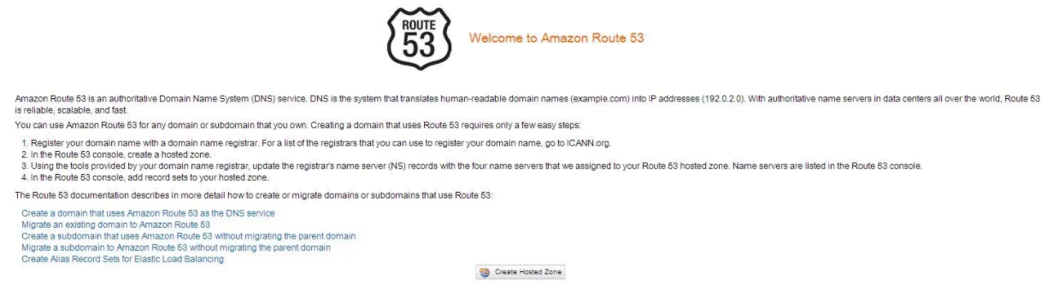First I will create a hosted zone for my wekanban.com. On Route 53 dashboard, I click “Create Hosted Zone” and create my “wekanban.com” domain.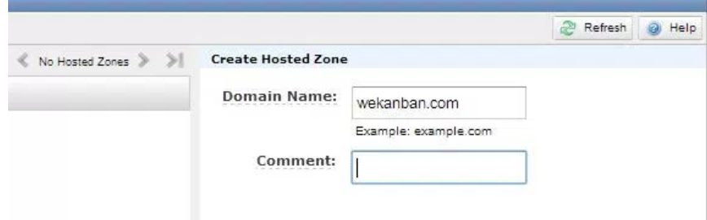

As you see in “Delegation set” there are some DNS servers. We have to update our registrar by providing these DNS servers and then AWS Route 53 will be able to answer our queries for our domain.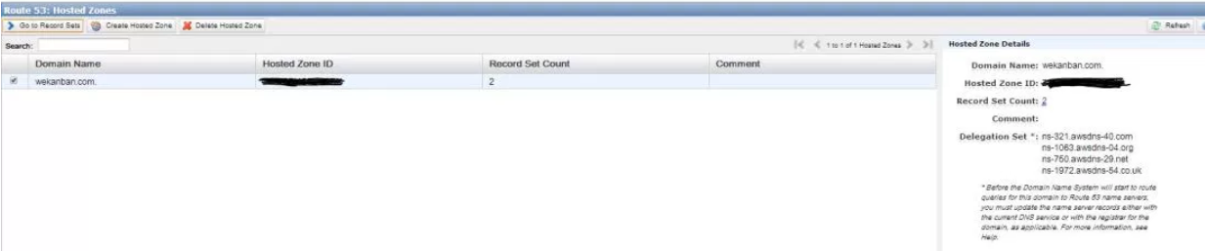 When we create a hosted zone, by default , 2 records are created automatically( NS ve SOA). It is important that we shouldn’t delete or change these records.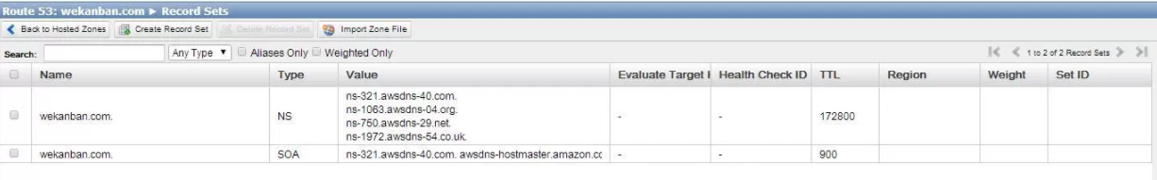We can now create our records for our domain. Route 53 supports different types of records. Refer to this [link](http://docs.aws.amazon.com/Route53/latest/DeveloperGuide/ResourceRecordTypes.html) to view the supported record types. There is an important record type which is “Alias”. Alias is a Route 53 specific record type and is used as a pointer for:

* ELB
* CloudFront
* S3 with a static website
* Other Route 53 record set

I will create two different records for my website. First one is an A record and will be for my “test.wekanban.com” website. The other one will be an Alias and I will point it to my ELB and serve my production website “www.wekanban.com”.

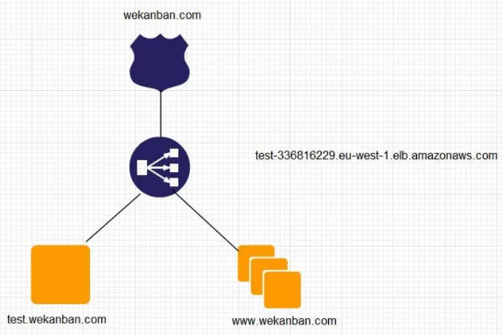

I’ve created 3 instances for my website.

For test.wekanban.com I will create an A record and use 54.72.137.212 value.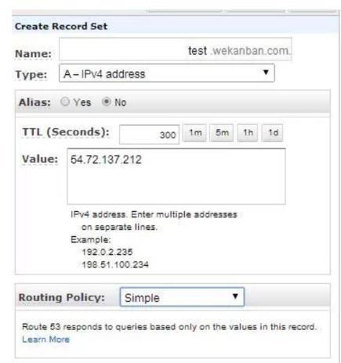

For www.wekanban.com I will create an Alias record and use my ELB as target.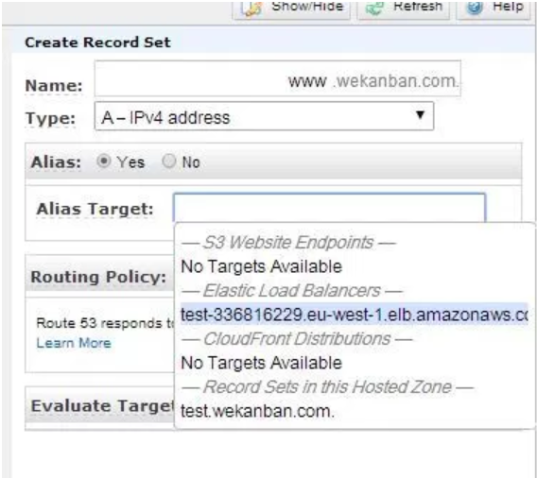

As you see there are other options like routing policy and evaluate target health. I will explain them later.

It is time to test our records now.

[](https://i0.wp.com/www.awsomeblog.com/wp-content/uploads/2014/05/created_records.jpg)

Our test for test.wekanban.com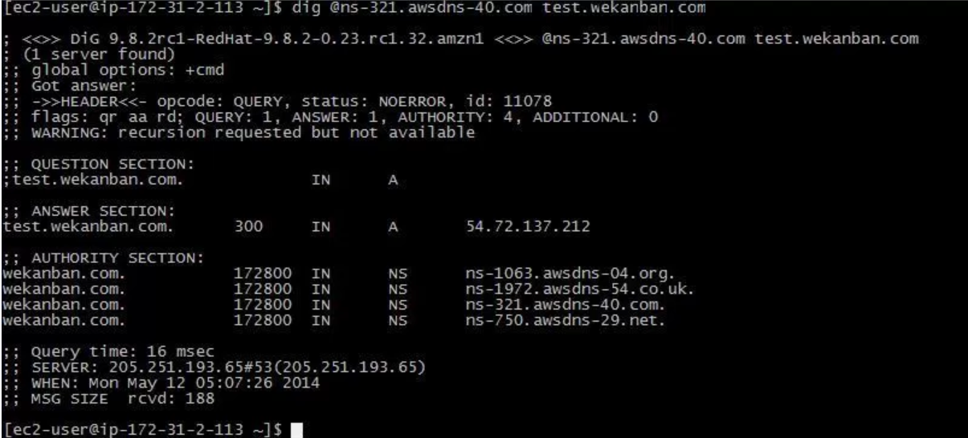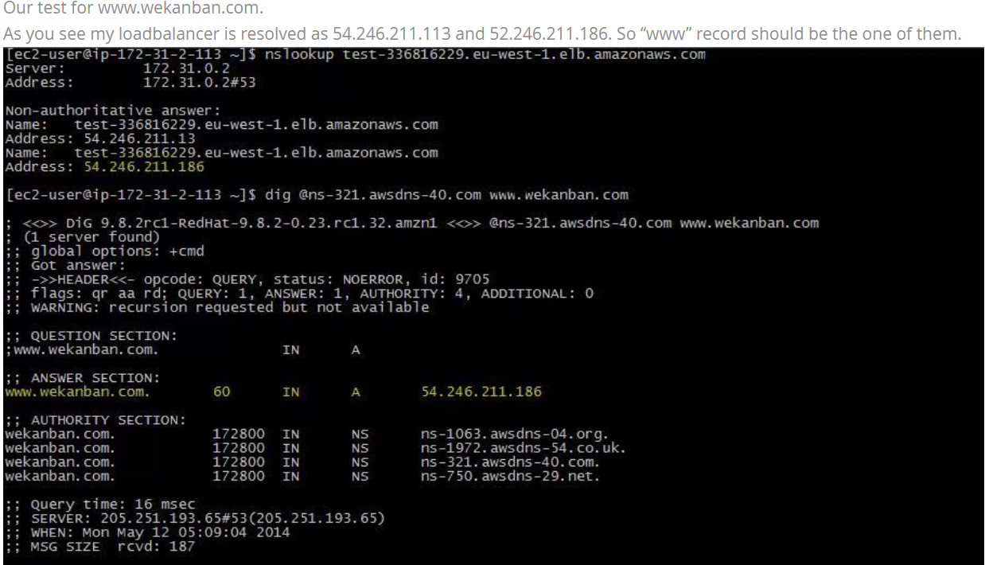

If you will migrate your DNS server to AWS Route 53, you can use “import zone file” option. There are some [limitations](http://docs.aws.amazon.com/Route53/latest/DeveloperGuide/rrs-changes-import-console.html) to use this option, like, the hosted zone must be empty and Route 53 ignores the SOA and NS records in the zone file.

Let’s import our sample zone file.

After creating hosted zone, I click “Import Zone File”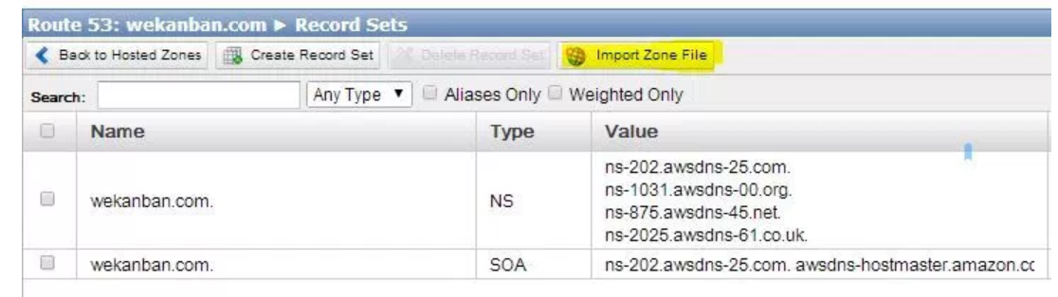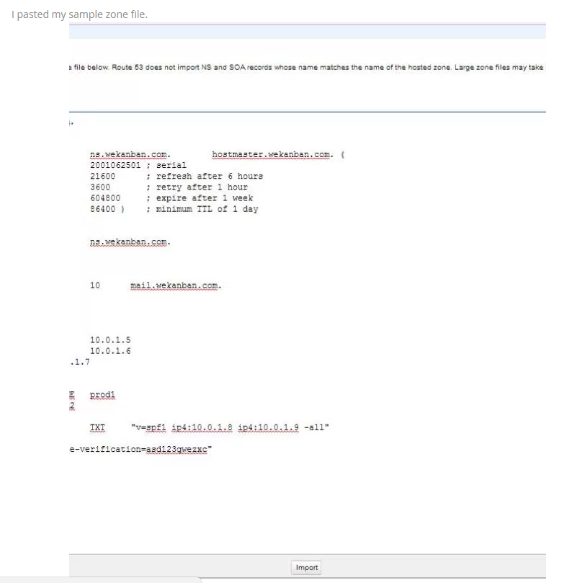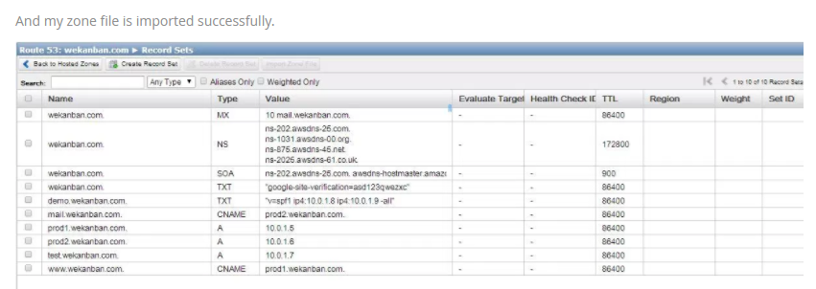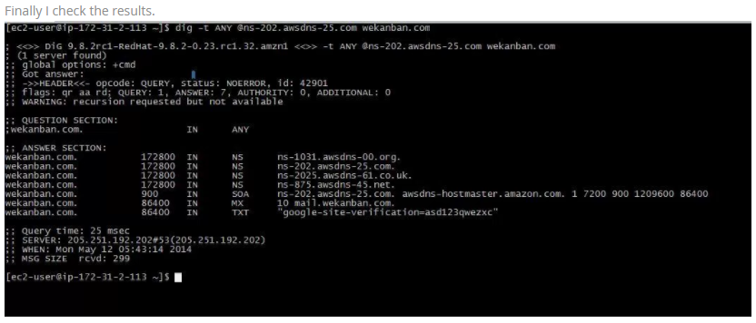

# Amazon Web Services Route 53 Part 2 – Routing Policies

**Today I will continue to explain Amazon Route 53 service and routing policies. Routing policies are used with record sets and enables us to configure failover scenarios like active-active and active-passive.** Currently Amazon Route 53 supports four types of routing policies; simple, weighted, latency and failover. I will explain them step by step by giving examples. Let’s start…

**Simple routing policy** is used only for a specific record like A,MX,NS etc. In this way, our DNS query will resolve to only one ip/host like:

[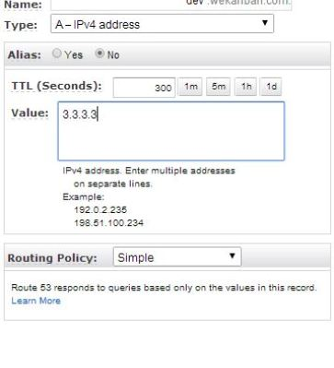](https://i1.wp.com/www.awsomeblog.com/wp-content/uploads/2014/05/simple.jpg)

As you see I created an A record as “dev.wekanban.com” and used simple record set that resolves as 3.3.3.3

**Weighted routing policy** enables us to reply to a single DNS queries with different ip addresses. Imagine that we have two EC2 instances and have different instance types, m3.medium and m3.large. Since one of the instances have more resources, we can forward more traffic to it by using weighted routing policy. And also we may want to test our new deployed code on real traffic without effecting our whole clients/visitors. Again we can use weighted routing policy to redirect a small portion of traffic to our new deployed instances. There is a formula to calculate the probability of the record being selected as below:

**Weight of the record set/Sum of the weights of the record sets**

For example, if I have two instances and give 10 weight to one instance(test- new code deployed) and 90 to the other instance(production- with old code) ==> 10/10+90=0,1 which means %10 of the traffic will be redirected to test instance. As seen below I create two weighted records. In weighted policy “Set ID” is used to describe the record. Remember that, If you give a “0” as weight, routing to this record is disabled if you didn’t associate it with health check. I will explain health checks in another post.

[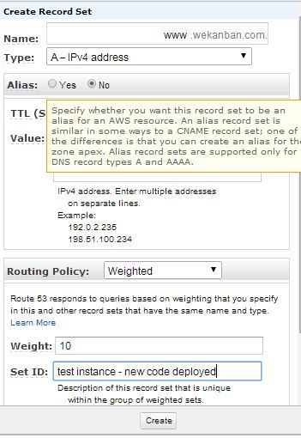](https://i0.wp.com/www.awsomeblog.com/wp-content/uploads/2014/05/weighted_10.jpg)[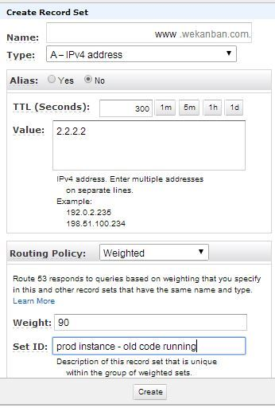](https://i2.wp.com/www.awsomeblog.com/wp-content/uploads/2014/05/weighted_90.jpg)

Now imagine that your website analysis shows that most visitors source countries are Japan and UK. In that case you may want to improve your website speed by lowering your latency between your website and visitors. In this example we can use **latency routing policy** and create two records as below. In that way visitors in Japan DNS queries will resolve as 6.6.6.6 and for the UK 5.5.5.5

In this example I didn’t use alias record but it is better and free to use alias for Elastic load balancers.

And finally we can create a **failover routing policy**. We can use this policy as a primary and a secondary site solution. For example you may have two instances and in case of one of them fails, DNS queries will resolve as secondary records. I have to say that before configuring failover policy, we have to create health checks for our records. Then we can associate with health checks and create our records.

[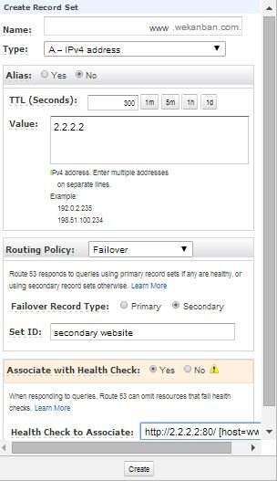](https://i0.wp.com/www.awsomeblog.com/wp-content/uploads/2014/05/secondary.jpg)[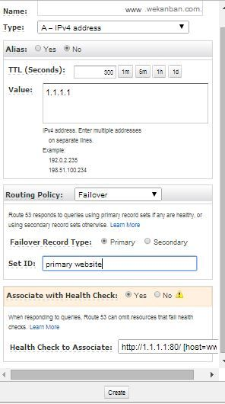](https://i0.wp.com/www.awsomeblog.com/wp-content/uploads/2014/05/primary.jpg)

If you have any question or comment please feel free to write and don’t forget to share please.

# Amazon Web Services Route 53 Part 3 – Health Checks

In this post I will continue with AWS Route 53 health checks. Health checks can be used for active-active and active -passive load balancing for our services. For example, we may have three web server instances with same configuration and these instances can be running in different regions. We can use health checks on thse instances and so DNS queries for our web site will respond as only healthy instances. By doing this we have an active-active failover system. We can create HTTP,HTTPS and TCP health checks on AWS route 53. So we can check of our instances for any protocol like web,mysql,ftp or custom tcp port. Today I will create a HTTP health check and also configure a SNS topic to be alerted if our health checks fail.

So Let’s start. I will use a demo topology like below. In this demo I will show both health check and failover policy.

[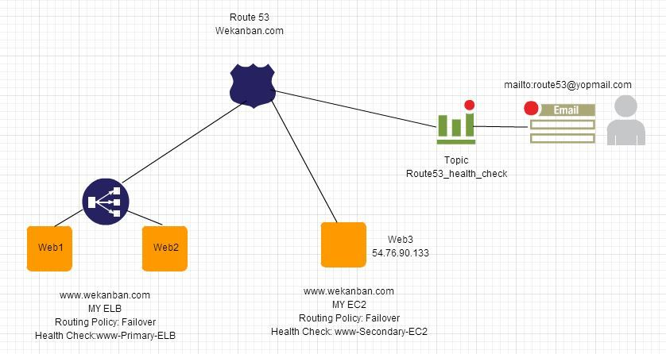](https://i1.wp.com/www.awsomeblog.com/wp-content/uploads/2014/05/topology.jpg)

First of all I will create an health check for my secondary site which is an EC2 instance.

[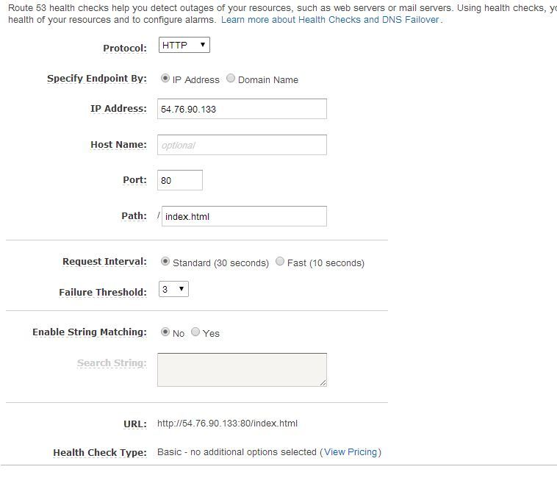](https://i2.wp.com/www.awsomeblog.com/wp-content/uploads/2014/05/check_web3.jpg)

I want to explain the meaning of the values here:  
Protocol : Which protocol we will check , HTTP, HTTPS or TCP?  
IP Address/Domain Name : The IPV4 address/Domain Name of the endpoint on which we want to perform health checks.  
Port : The port on the endpoint on which we want to perform the health checks.  
Hostname : The value we pass in the Host header in HTTP and HTTPS health checks. If we don’t specify this it will use the IP Address. For TCP protocol ,host header is not sent.  
Path: The path to perform health checks like index.html , healthcontrol.php etc  
Request Interval : The number of seconds between the each health check request. If you choose Fast , get ready for [additional cost](http://aws.amazon.com/route53/pricing/#HealthChecks)  
Failure Threshold : The number of consecutive health checks.  
Enable String Matching: If you want to search for a string in response body you can enable it.  
URL: The URL for health checks will be performed on.  
Health Check Type: Basic or Basic+additional options you enabled.

I will create records for ELB and EC2 by using failover policy.

**Record for ELB as an Alias. Record for EC2 as an A type.  
  
[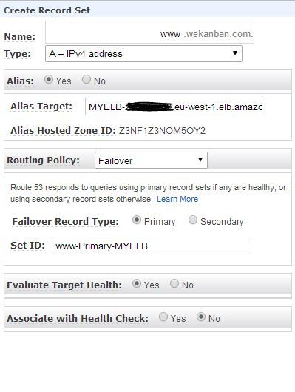](https://i1.wp.com/www.awsomeblog.com/wp-content/uploads/2014/05/record_elb.jpg) [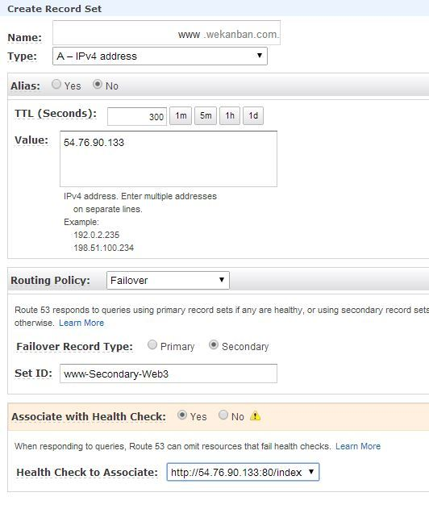](https://i1.wp.com/www.awsomeblog.com/wp-content/uploads/2014/05/record_ec2.jpg)**

Now we can test Route53 responses for our queries. As you see DNS query for my primary website is as expected, MYELB:

[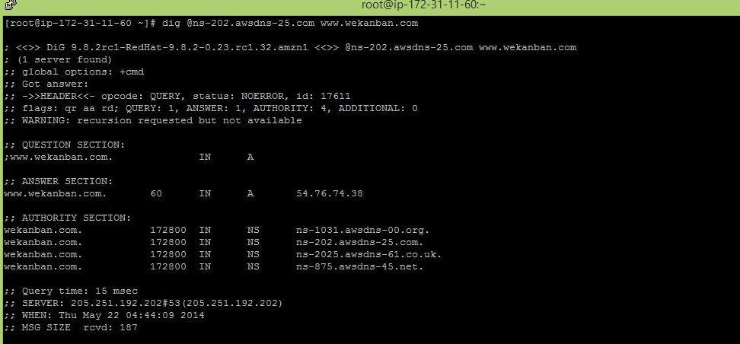](https://i1.wp.com/www.awsomeblog.com/wp-content/uploads/2014/05/dig11.jpg)

Now I will stop the apache services on my instances web1 and web2 and Route53 will forward my requests to my secondary website, EC2 54.76.90.133:

[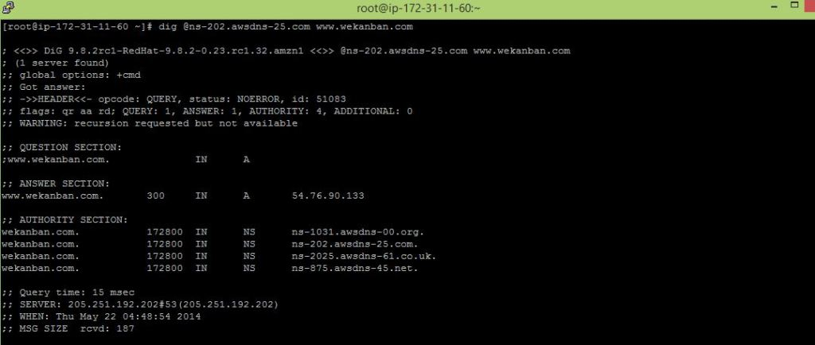](https://i0.wp.com/www.awsomeblog.com/wp-content/uploads/2014/05/dig21.jpg)

If I start the apache services on my instances again, Route53 will use my primary record set again, MY ELB:  
[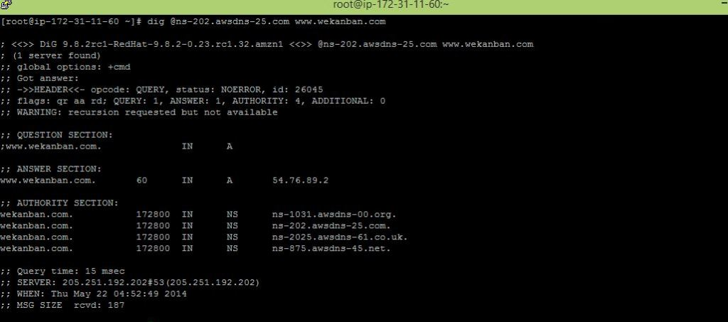](https://i2.wp.com/www.awsomeblog.com/wp-content/uploads/2014/05/dig3.jpg)

It is time to test the health check now. Before testing it I will create an alarm and create a notification for it. Then I will stop the apache service on my secondary website EC2, and wait for SNS email.

I will create an alarm:  
[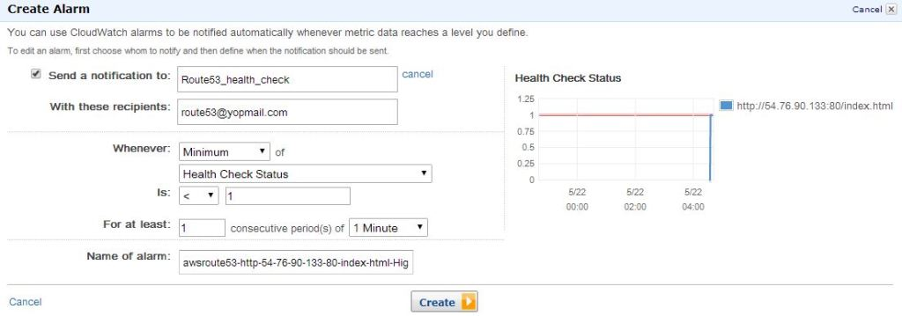](https://i0.wp.com/www.awsomeblog.com/wp-content/uploads/2014/05/create_alarm.jpg)

I’ve created it and it seem ok as our apache server is running:

[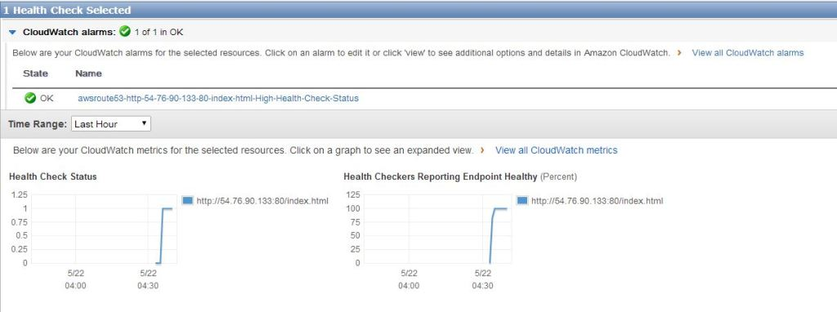](https://i1.wp.com/www.awsomeblog.com/wp-content/uploads/2014/05/created_alarm.jpg)

I will stop it now and wait for the SNS email:

[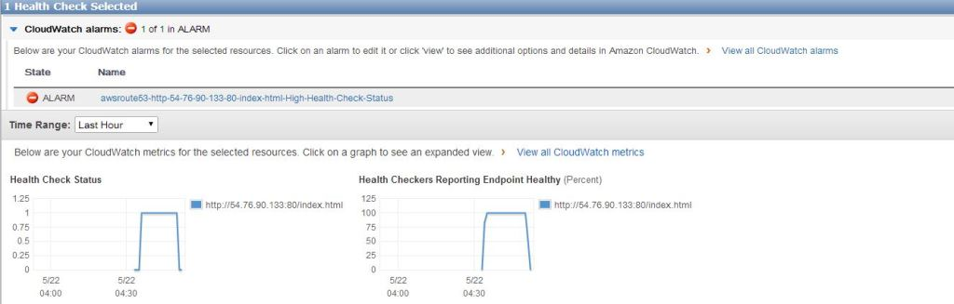](https://i2.wp.com/www.awsomeblog.com/wp-content/uploads/2014/05/unhealthy.jpg)

[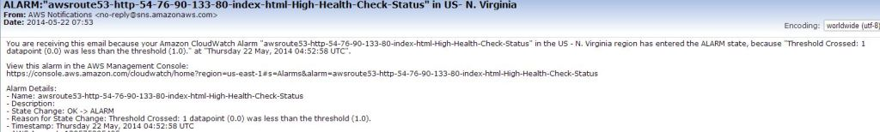](https://i2.wp.com/www.awsomeblog.com/wp-content/uploads/2014/05/sns_email.jpg)

Again if I start apache on my EC2, alarm will be ok and SNS will send an email again ( if you configured Cloudwatch alarm for sending notification for the status “ok”)

[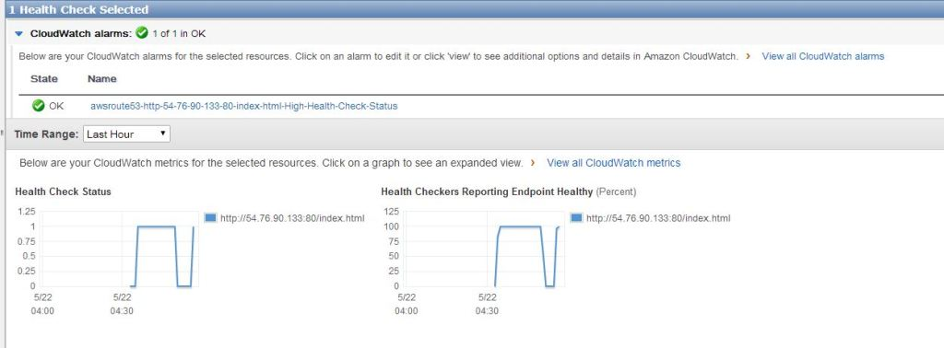](https://i2.wp.com/www.awsomeblog.com/wp-content/uploads/2014/05/healthy_again.jpg)

[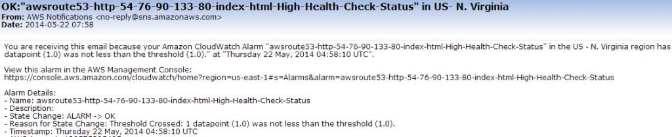](https://i2.wp.com/www.awsomeblog.com/wp-content/uploads/2014/05/sns_email_ok.jpg)

As you see configuration of health checks are so easy. You can create mixed failover scenarios by using latency record set and weighted records.

$ host lexile.com

lexile.com has address 54.225.175.222

lexile.com has address 50.19.122.200

lexile.com has IPv6 address 2406:da00:ff00::36e1:afde

lexile.com has IPv6 address 2406:da00:ff00::3213:7ac8

lexile.com mail is handled by 30 alt2.aspmx.l.google.com.

lexile.com mail is handled by 40 aspmx2.googlemail.com.

lexile.com mail is handled by 50 aspmx3.googlemail.com.

lexile.com mail is handled by 10 aspmx.l.google.com.

lexile.com mail is handled by 20 alt1.aspmx.l.google.com.